RGB D MMPose and MHR ROM Evaluation
Manual annotations compared with RGB D MMPose and fitted 3D body model measurements

Evaluation Method

Using RGB-D
We evaluated an RGB D and MMPose based range of motion measurement pipeline against manual annotator measurements. Each evaluation image shows two paired RGB D frames of the same participant: the side view is displayed on the left and the front view on the right. Because the recordings are not perfectly synchronized, the selected frames represent the same movement phase rather than necessarily the exact same instant.
For each movement, the annotator used the view with the clearest anatomical landmarks. This means the required landmarks were visible with minimal or no occlusion from another body segment, clothing, furniture, or the floor, and had usable depth information. The other view was retained for reference and, where available, for an additional MMPose comparison.
In the figures, red outlines, labels, and lines represent MMPose landmarks and measurements. Green filled points, labels, and lines represent the manual annotator's landmarks and measurements. The angle cards below each image show the corresponding computed 3D angle and absolute error.
The RGB D and MMPose pipeline achieved errors below approximately 3 degrees for many suitable comparisons, particularly when the side view provided clear landmarks and reliable depth. However, the results were sensitive to small changes in pixel placement because individual image pixels are converted into depth dependent 3D coordinates. Noisy, inaccurate, or occluded depth values can therefore produce larger angular errors. Differences between front and side view estimates were also observed, especially when landmarks were occluded or the paired frames represented slightly different movement positions.
The current RGB D and MMPose approach has an important limitation: it maps individual 2D landmarks to 3D using the depth value at each pixel. If a landmark is occluded, the sampled depth may belong to another body surface or the background. Small pixel shifts can also change the reconstructed 3D point and therefore the angle. Direct RGB D ROM is most appropriate when the required landmarks are visible, unobstructed, and have reliable depth, such as elbow flexion viewed from the side.

Using MHR
The MHR body model provides a complementary approach by fitting a coherent 3D skeleton to the subject. Joint positions are constrained by the body model rather than being determined by isolated RGB D pixels, making the resulting angles less sensitive to individual depth outliers and partial occlusion. This should make the MHR measurements more stable and repeatable, but they remain dependent on the quality of model fitting and should not be treated as ground truth without clinical validation.

Results
Table 1 Absolute angle error in degrees
Test | Side-view error | Front-view error
Right shoulder flexion | 1.1 deg / 4.3 deg | 11.7 deg / 29.3 deg
Right shoulder extension | 1.5 deg / 0.0 deg | 12.6 deg / 4.1 deg
Right shoulder abduction | n/a / n/a | 1.7 deg / 3.4 deg
Right shoulder internal rotation | n/a / n/a | 2.2 deg / 0.7 deg
Right shoulder external rotation | n/a / n/a | 2.3 deg / 0.9 deg
Right elbow flexion | 0.1 deg / 0.7 deg | 54.7 deg / 46.7 deg
Right hip flexion | 0.9 deg / 1.1 deg | 39.0 deg / 46.5 deg
Right hip abduction | 0.4 deg / 2.1 deg | 3.5 deg / 25.2 deg
Right knee flexion | 2.9 deg / 0.4 deg | 23.0 deg / 10.9 deg
Right knee extension | 0.3 deg / 3.6 deg | 67.1 deg / 81.0 deg
Right ankle plantarflexion | 0.8 deg / 4.3 deg | n/a / n/a
The two values in each cell correspond to the two saved examples for that test. The side and front errors are calculated as the absolute difference between the manual annotator angle and the MMPose angle from the corresponding view. n/a indicates that a MMPose comparison was unavailable for that view.

Figure Legend
Red outlines, labels, and lines represent MMPose landmarks and measurements.
Green filled points, labels, and lines represent manual annotator landmarks and measurements.
Blue to red depth overlay represents nearer to farther depth.
Black regions represent invalid or unavailable depth.
Detailed RGB D and MMPose figures are provided in Appendix A (Figures A1 to A22). Detailed MHR body model visualizations are provided in Appendix B (Figures B1 to B9).

Appendix A RGB D MMPose Figures
The following figures show the paired side and front views for each saved ROM annotation, with the corresponding MMPose and manual measurements overlaid.
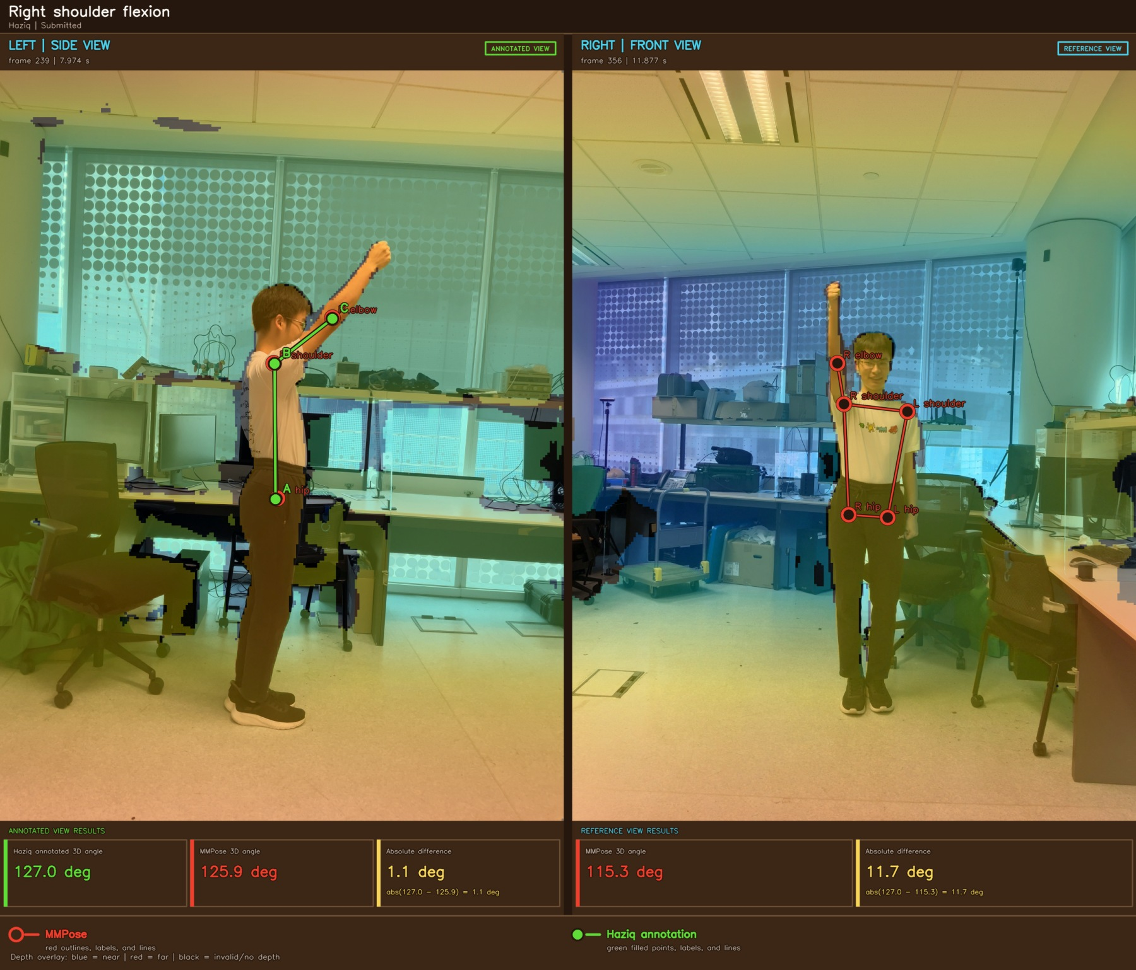
Figure A1 Right shoulder flexion example 1

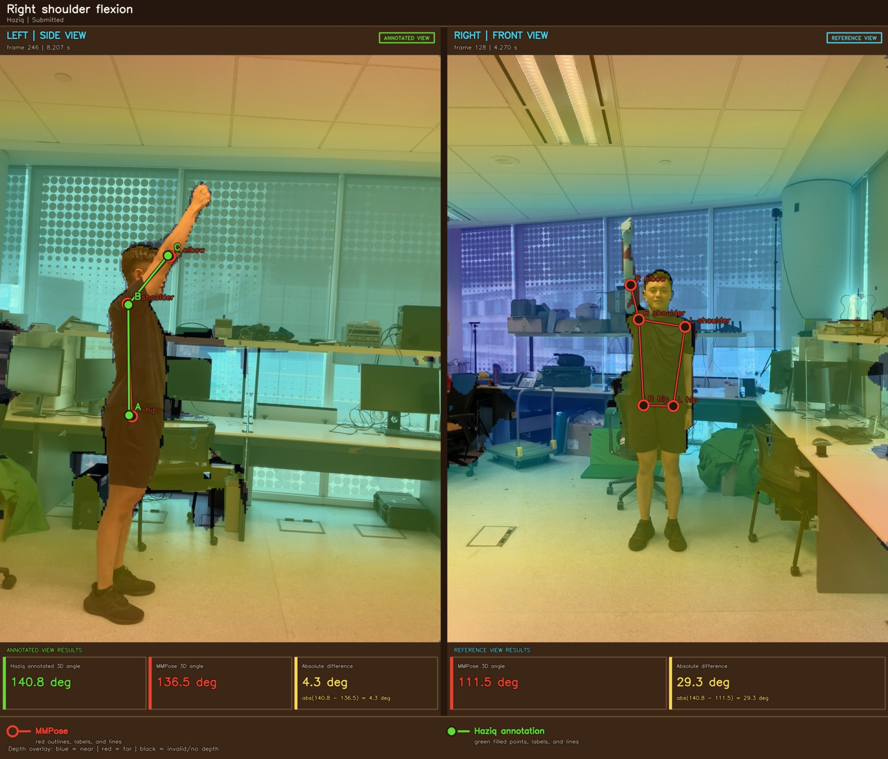
Figure A2 Right shoulder flexion example 2

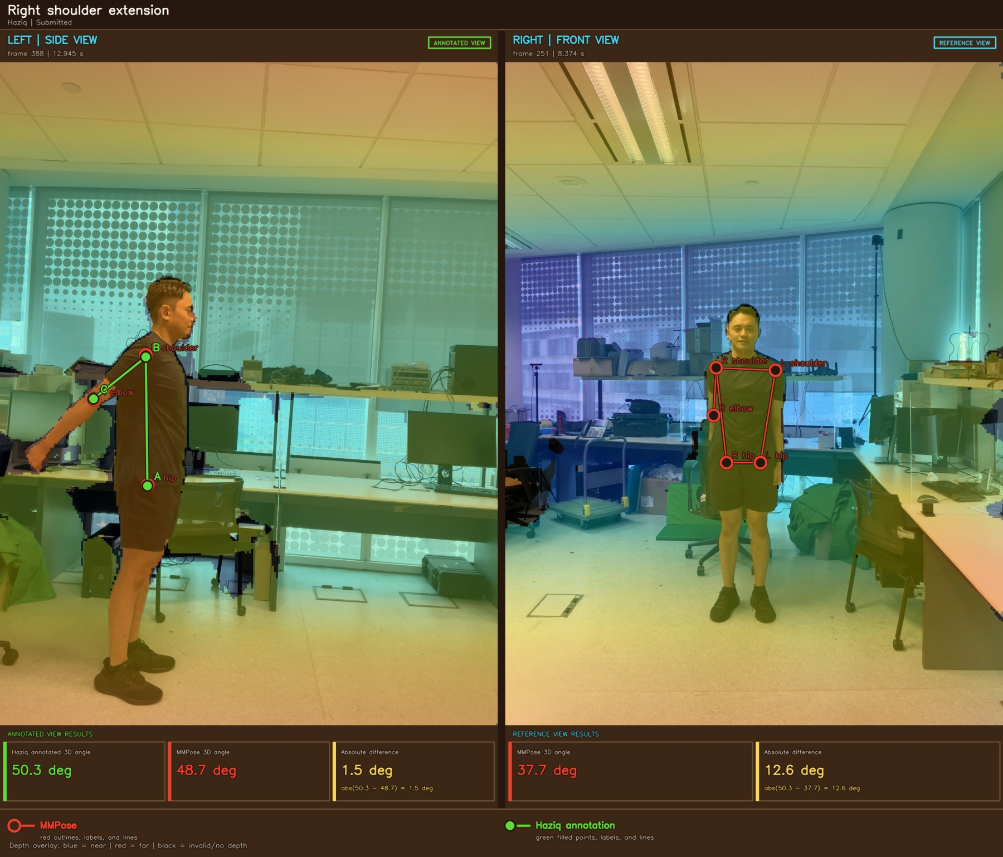
Figure A3 Right shoulder extension example 1

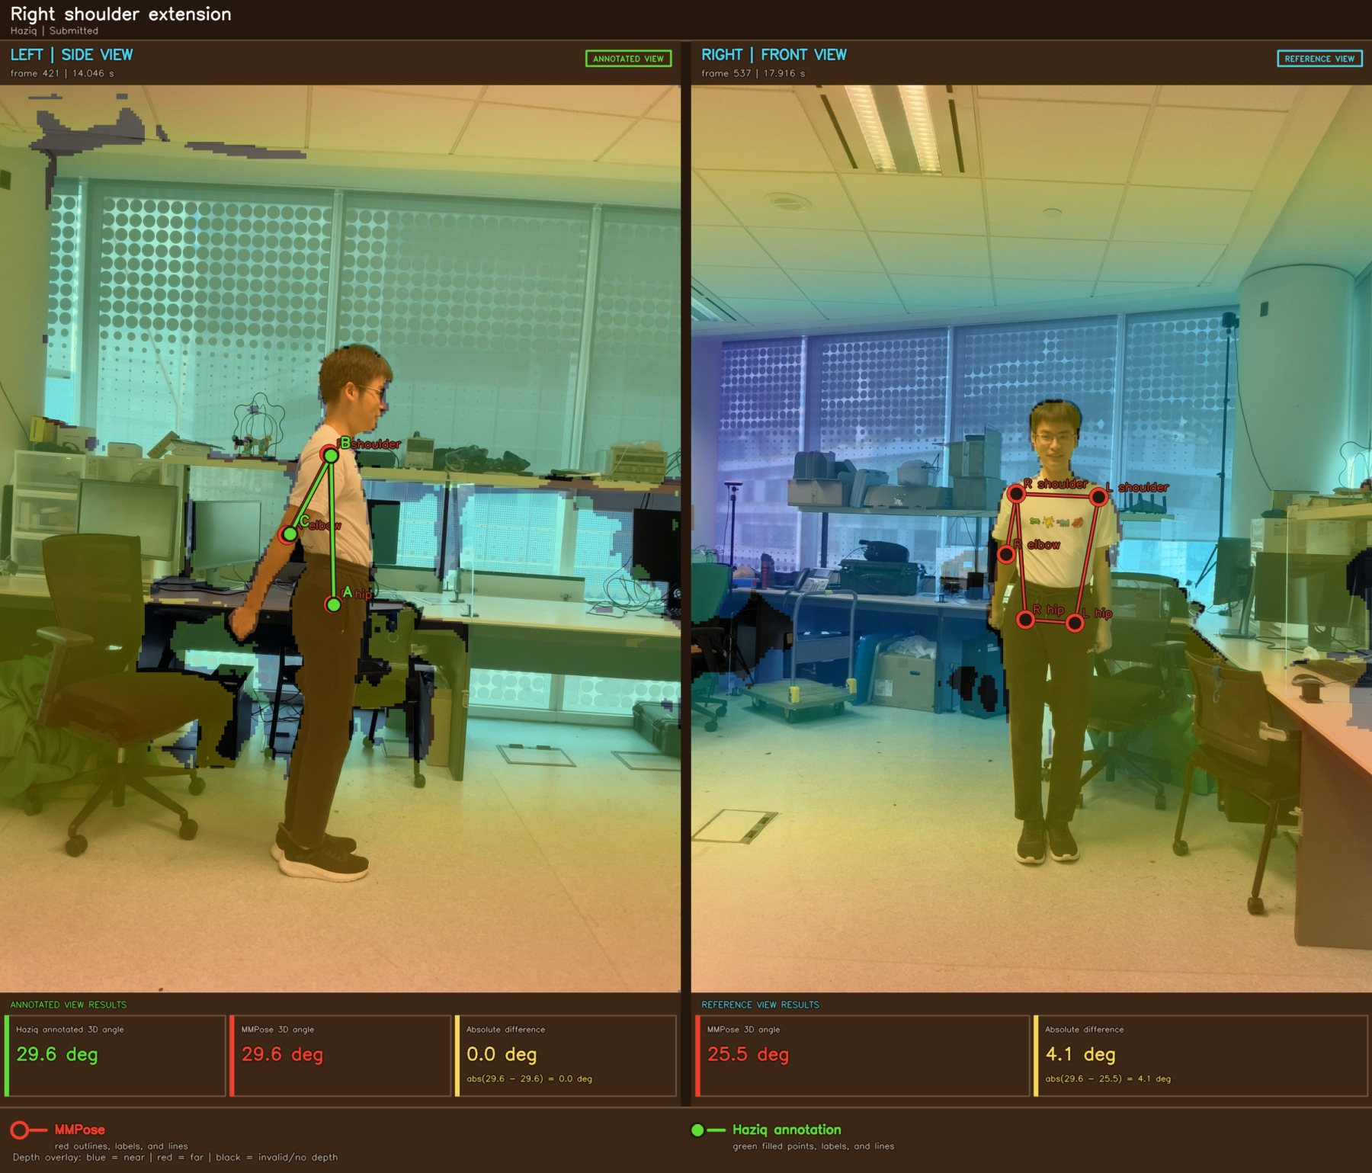
Figure A4 Right shoulder extension example 2

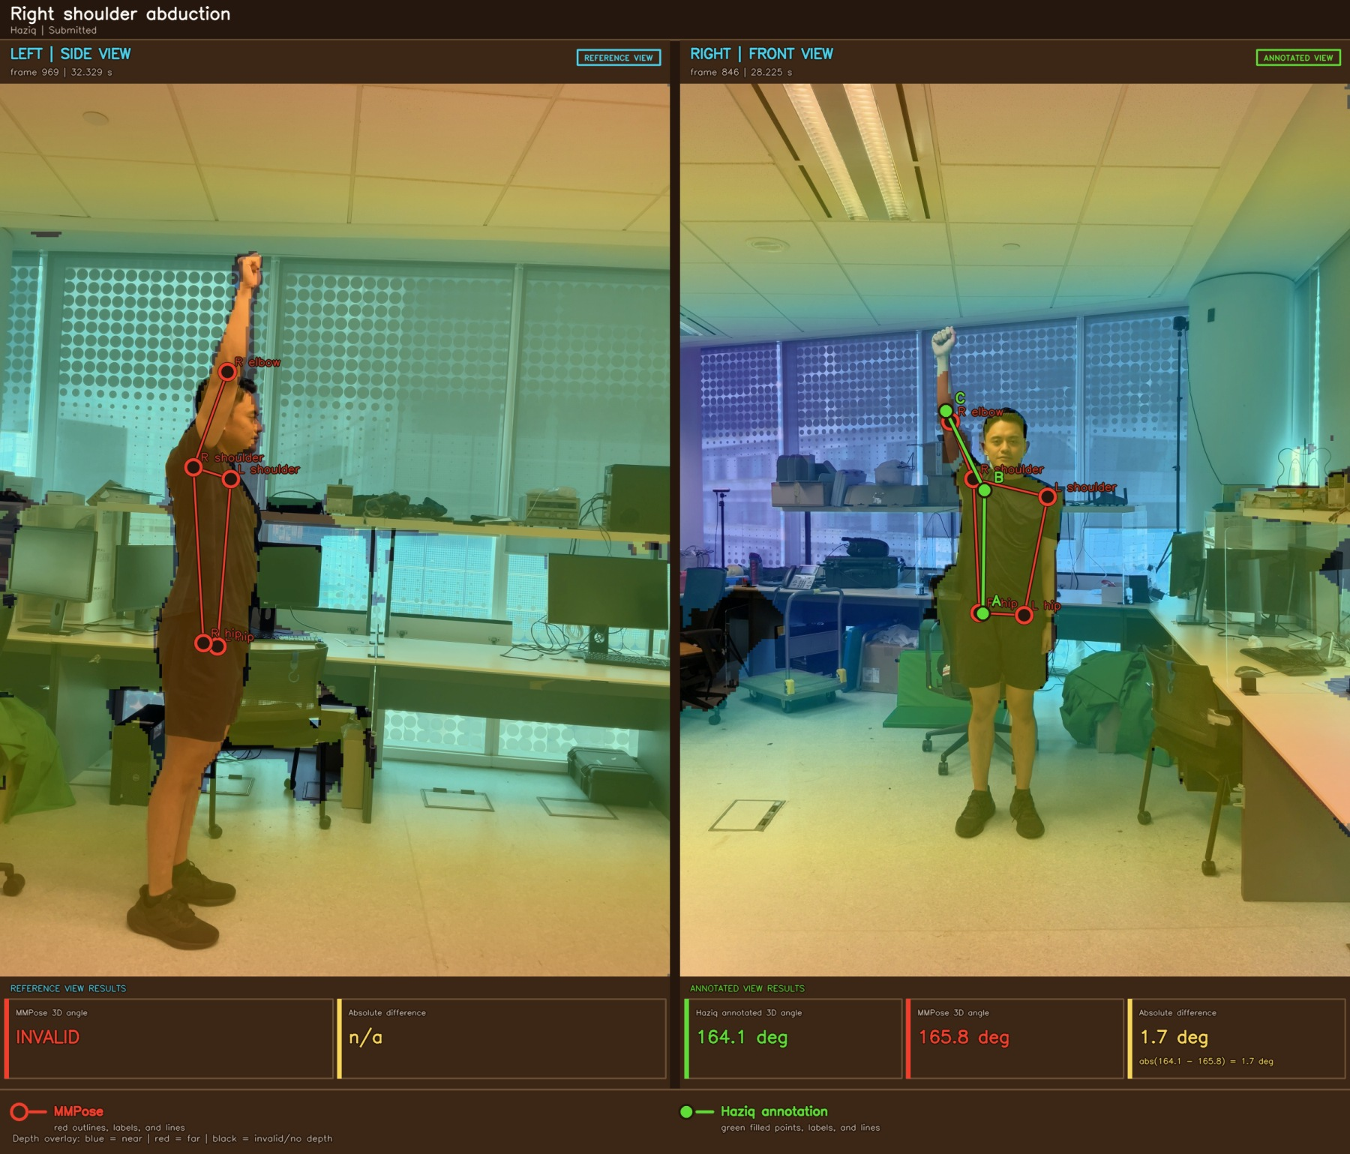
Figure A5 Right shoulder abduction example 1

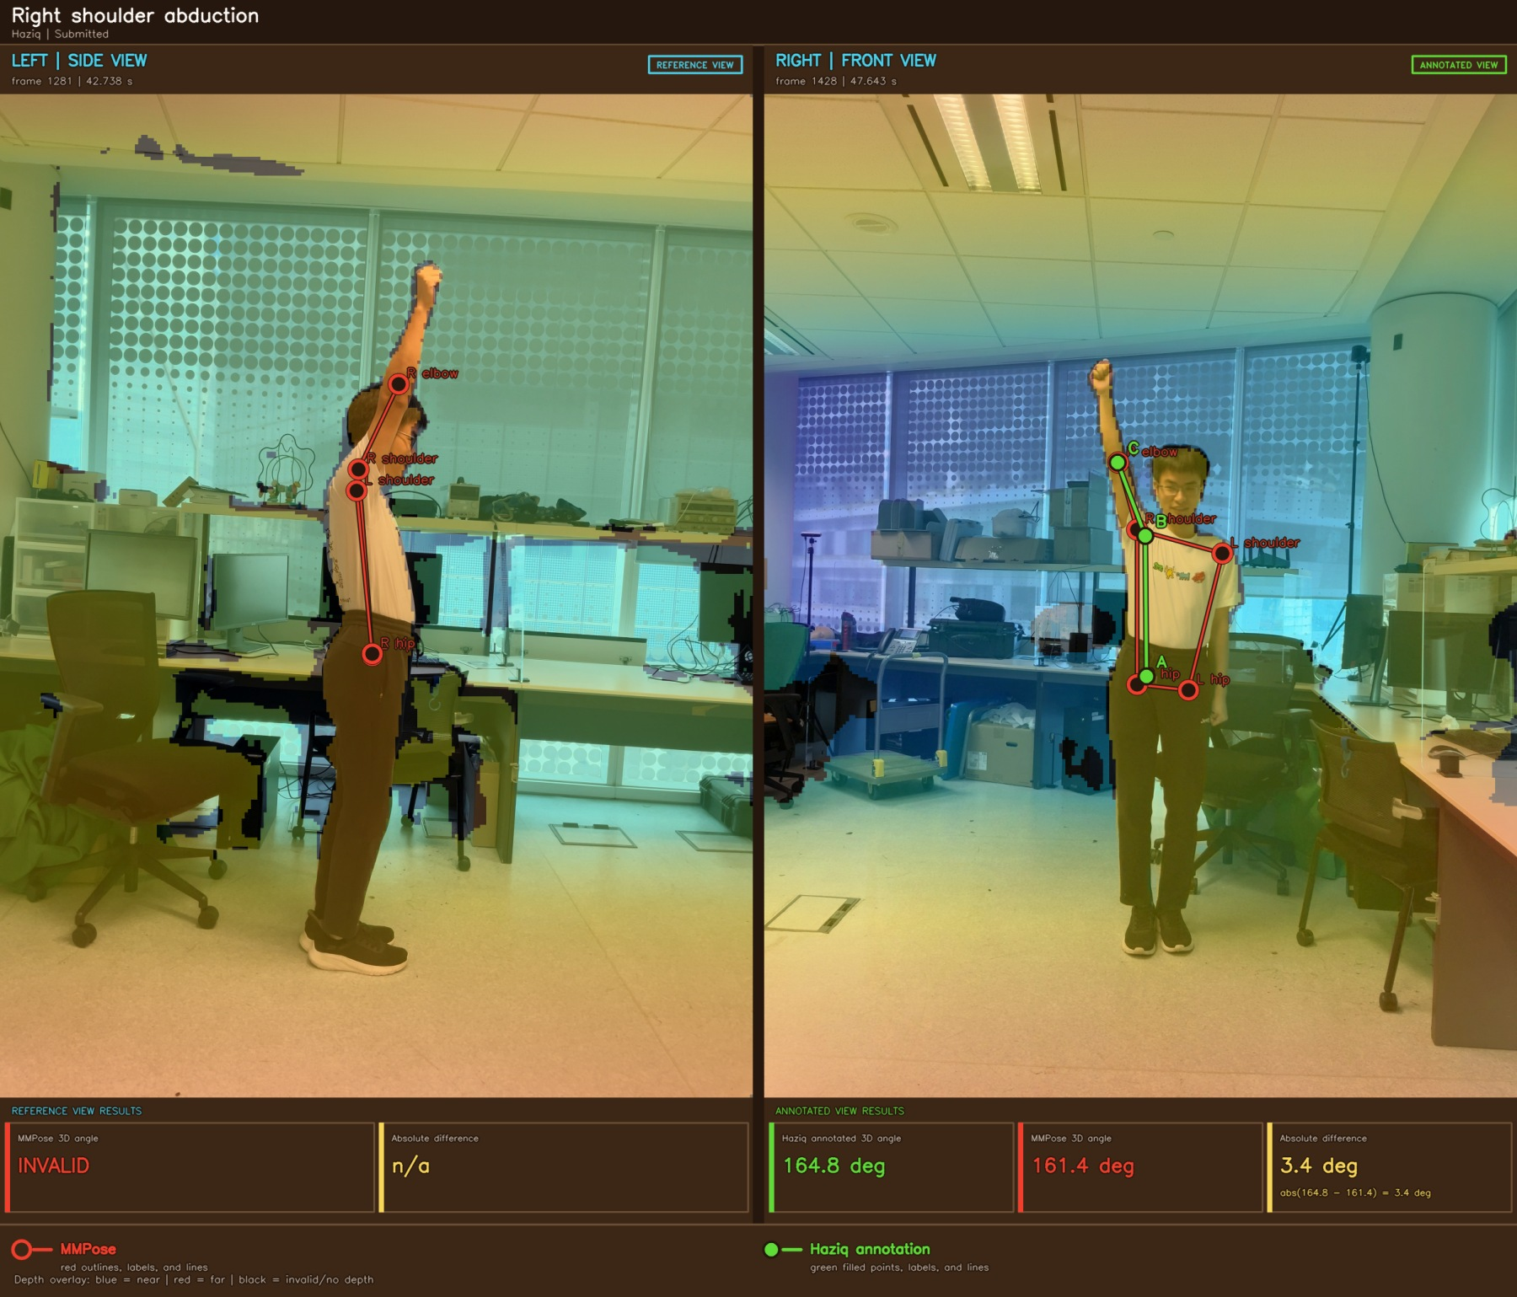
Figure A6 Right shoulder abduction example 2

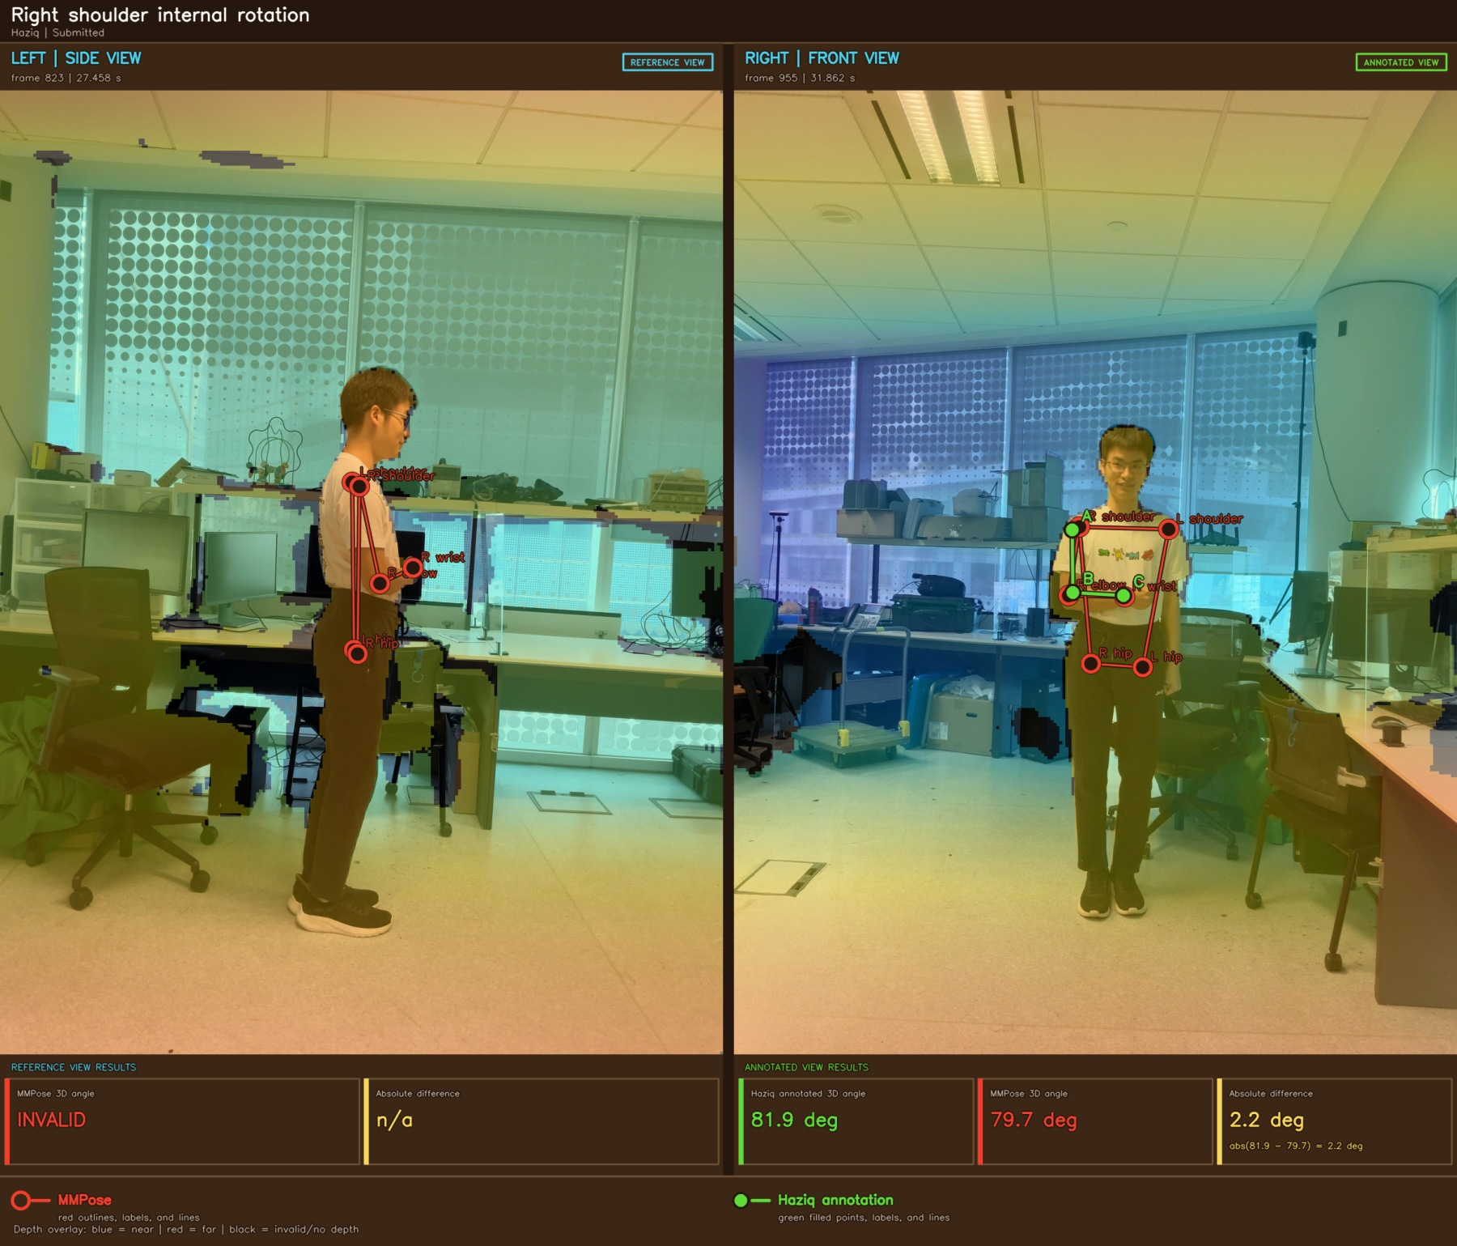
Figure A7 Right shoulder internal rotation example 1

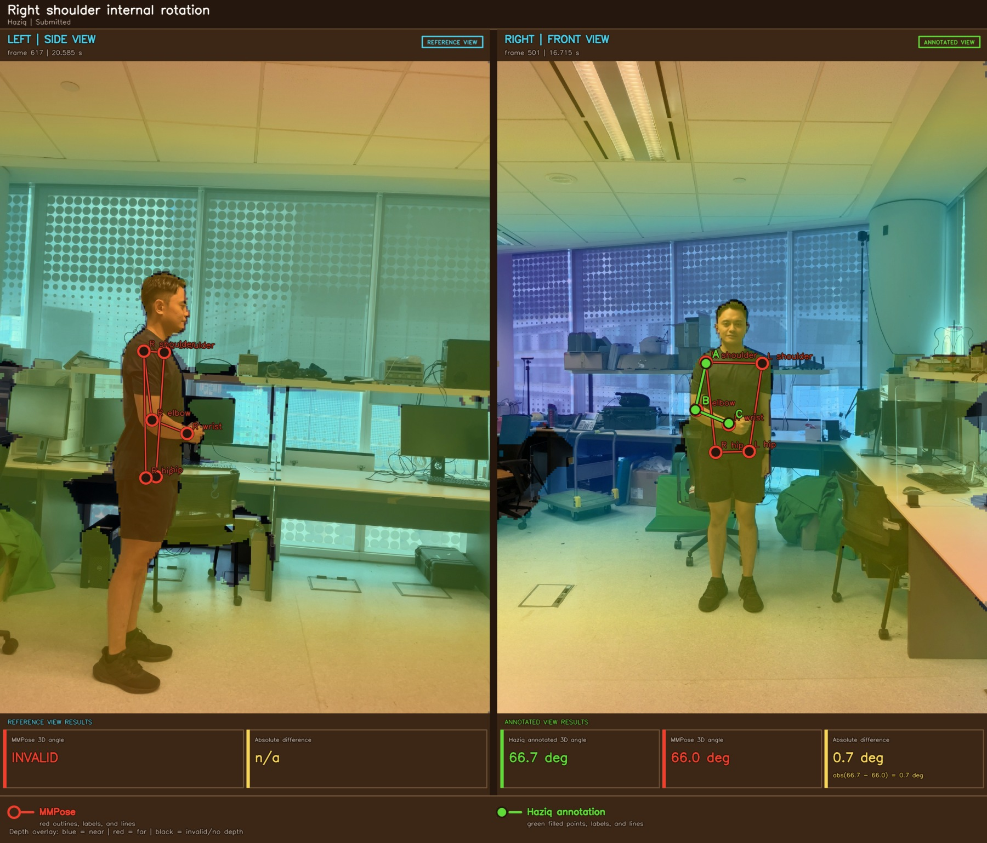
Figure A8 Right shoulder internal rotation example 2

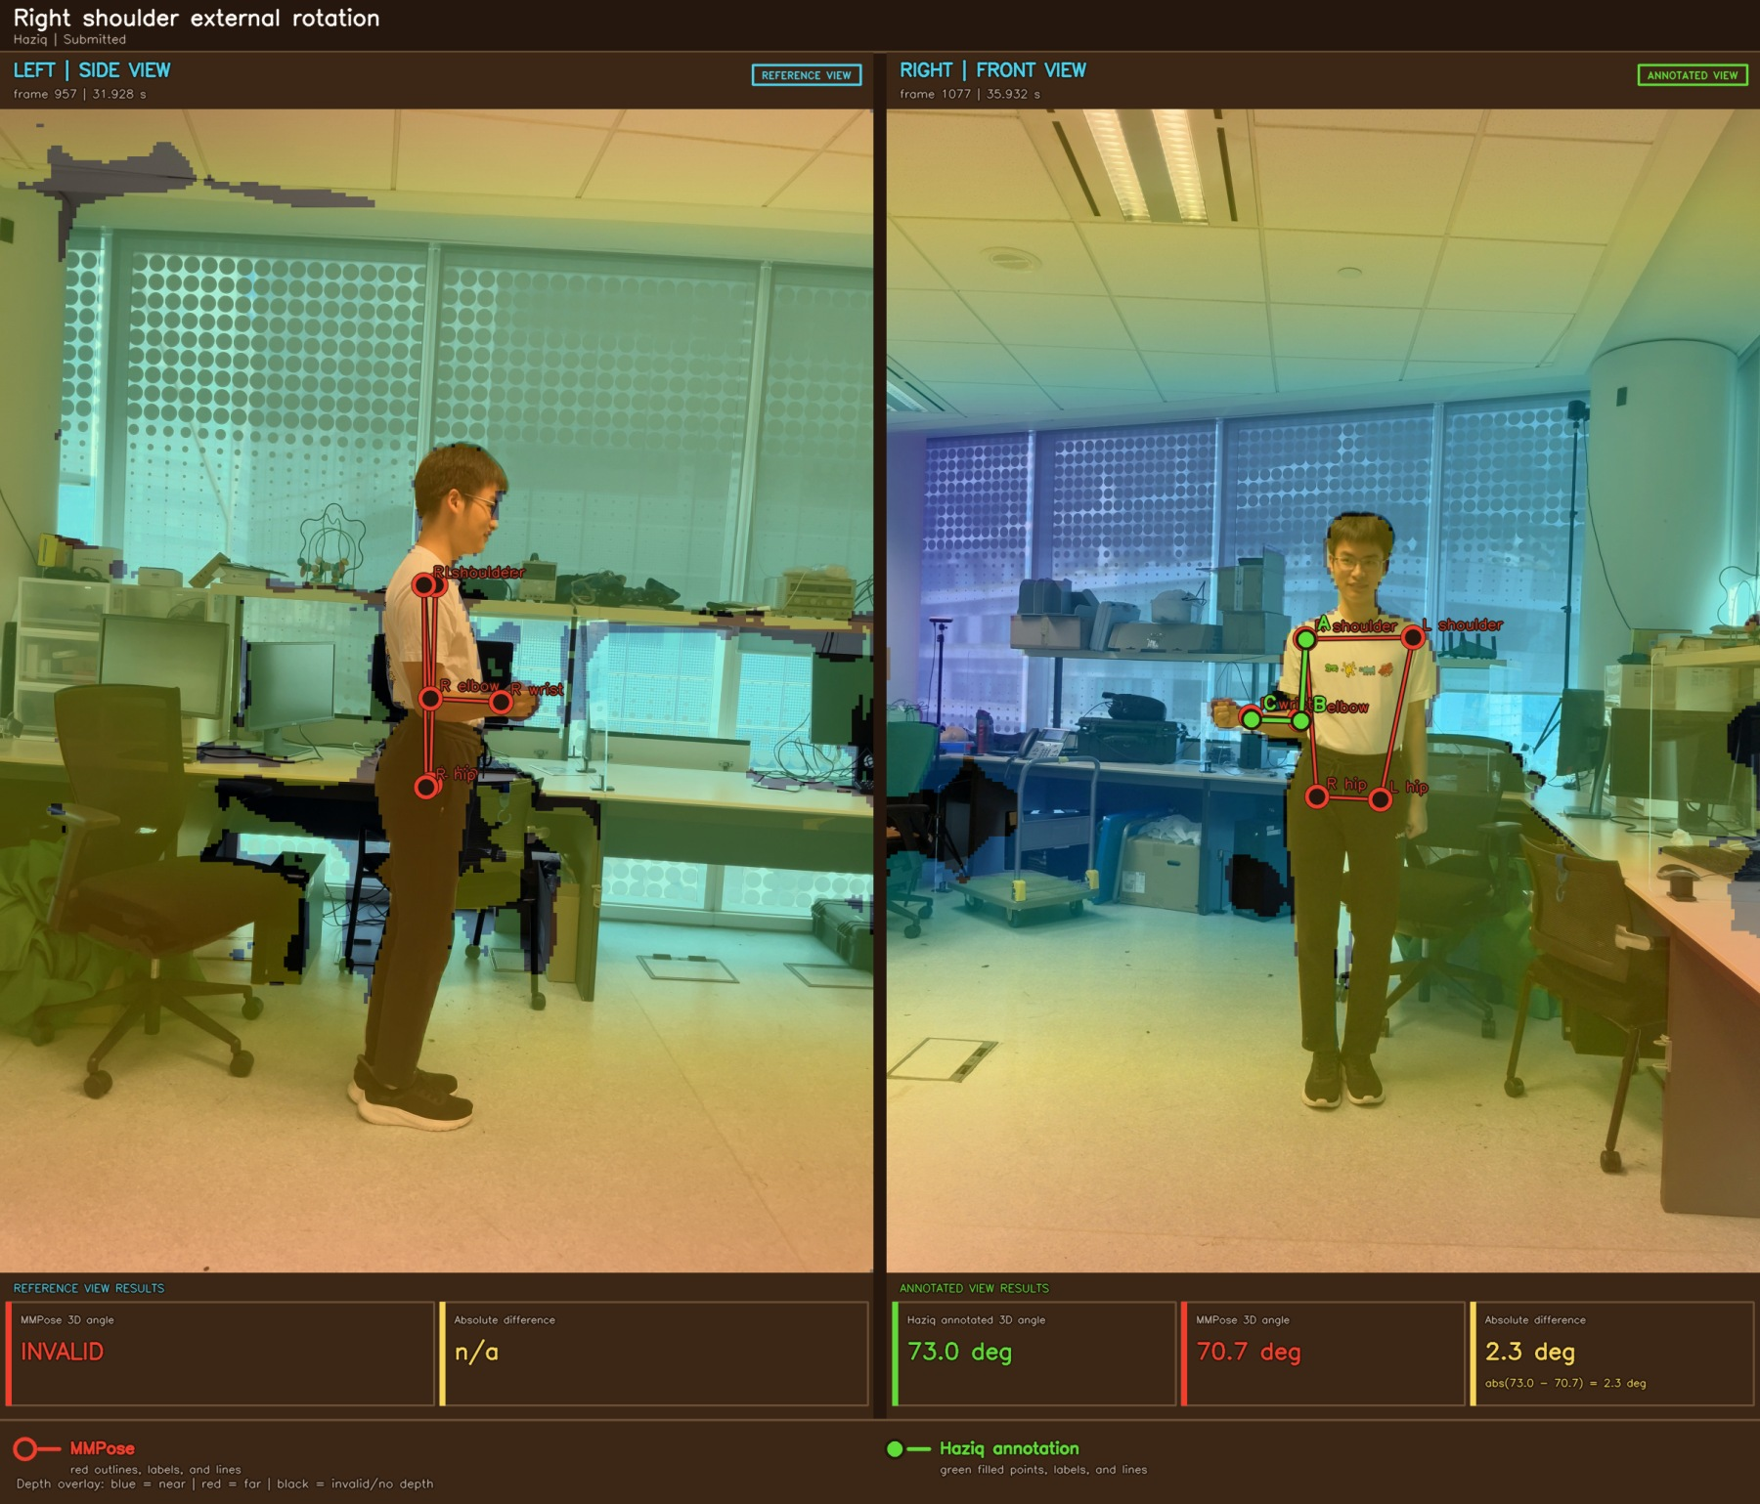
Figure A9 Right shoulder external rotation example 1

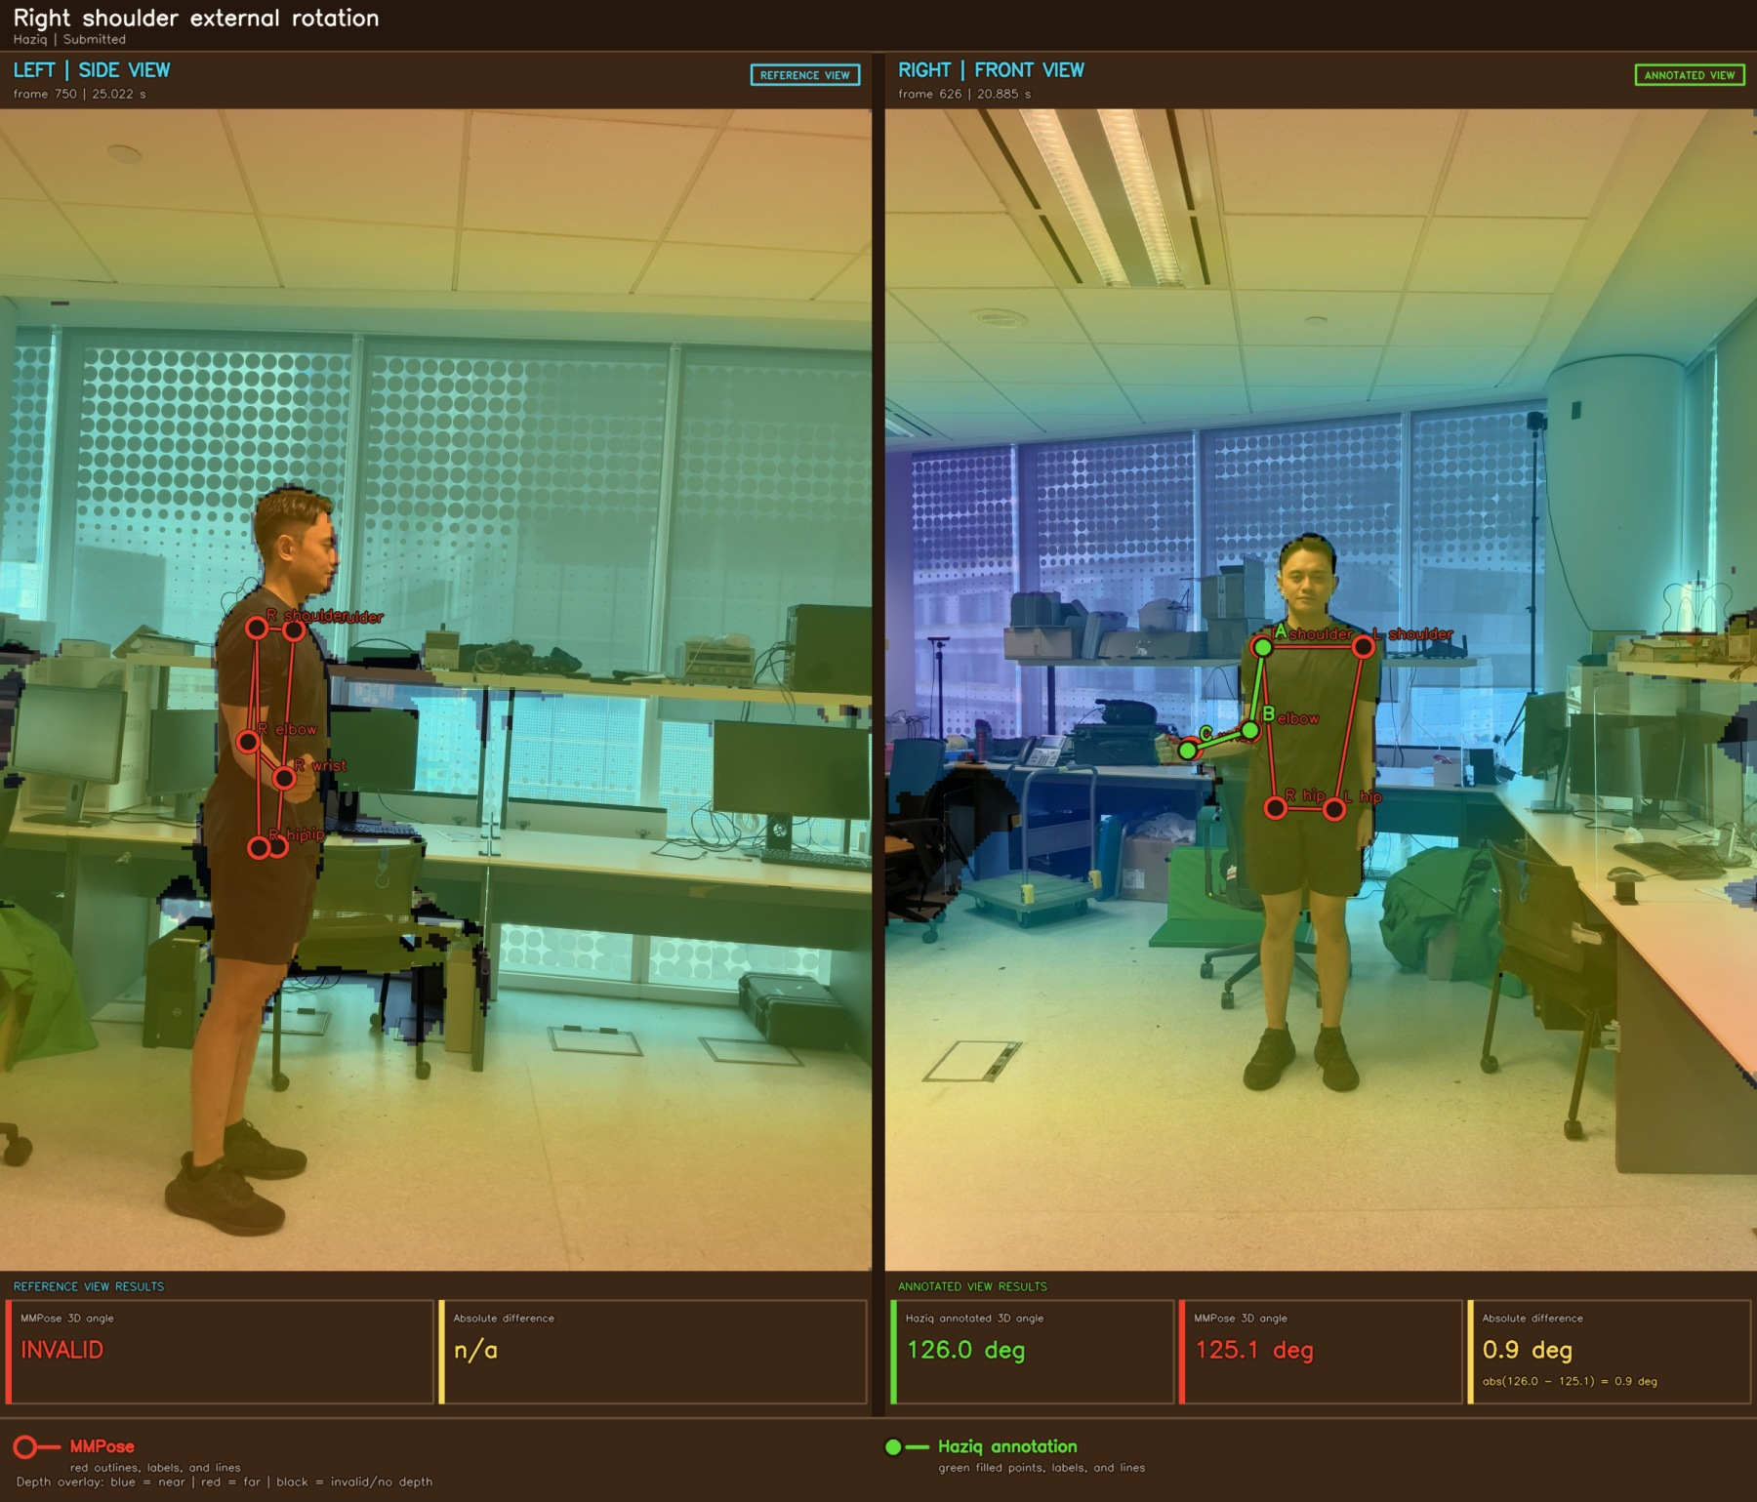
Figure A10 Right shoulder external rotation example 2

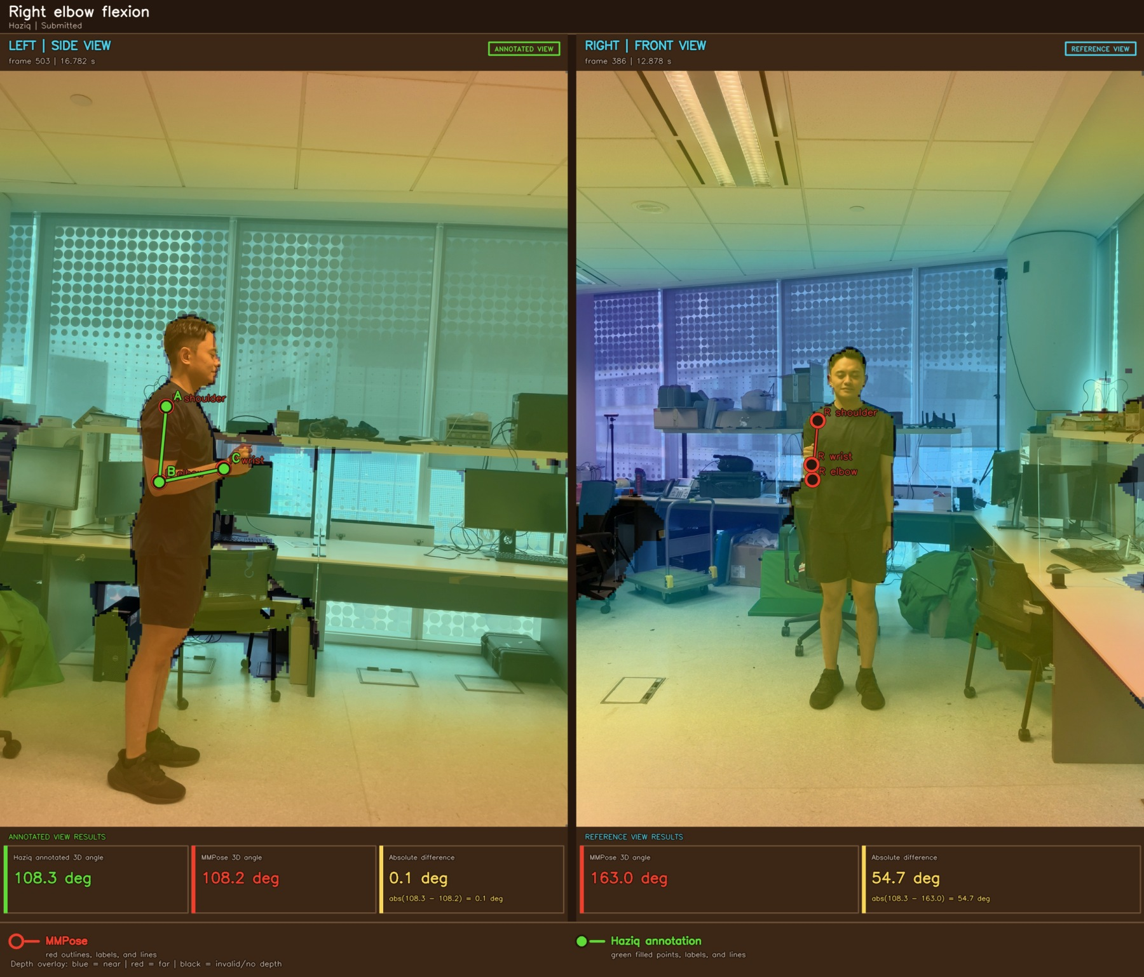
Figure A11 Right elbow flexion example 1

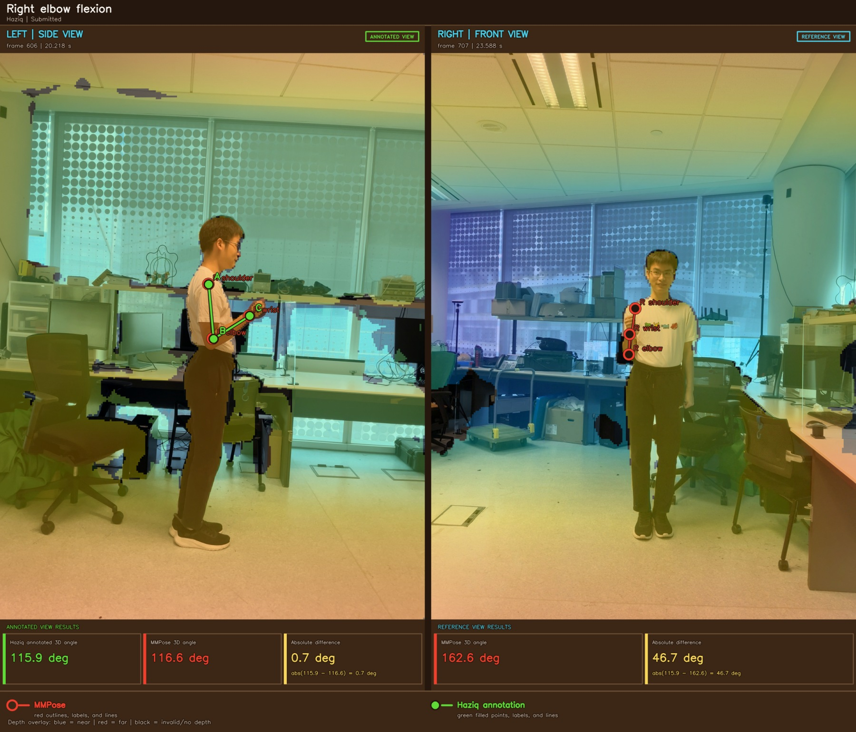
Figure A12 Right elbow flexion example 2

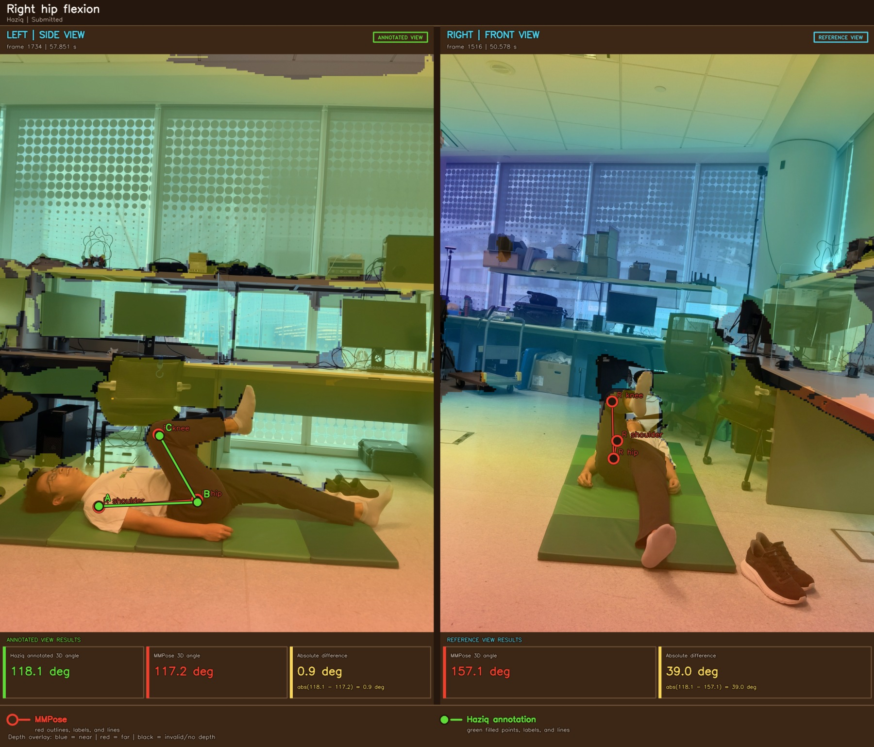
Figure A13 Right hip flexion example 1

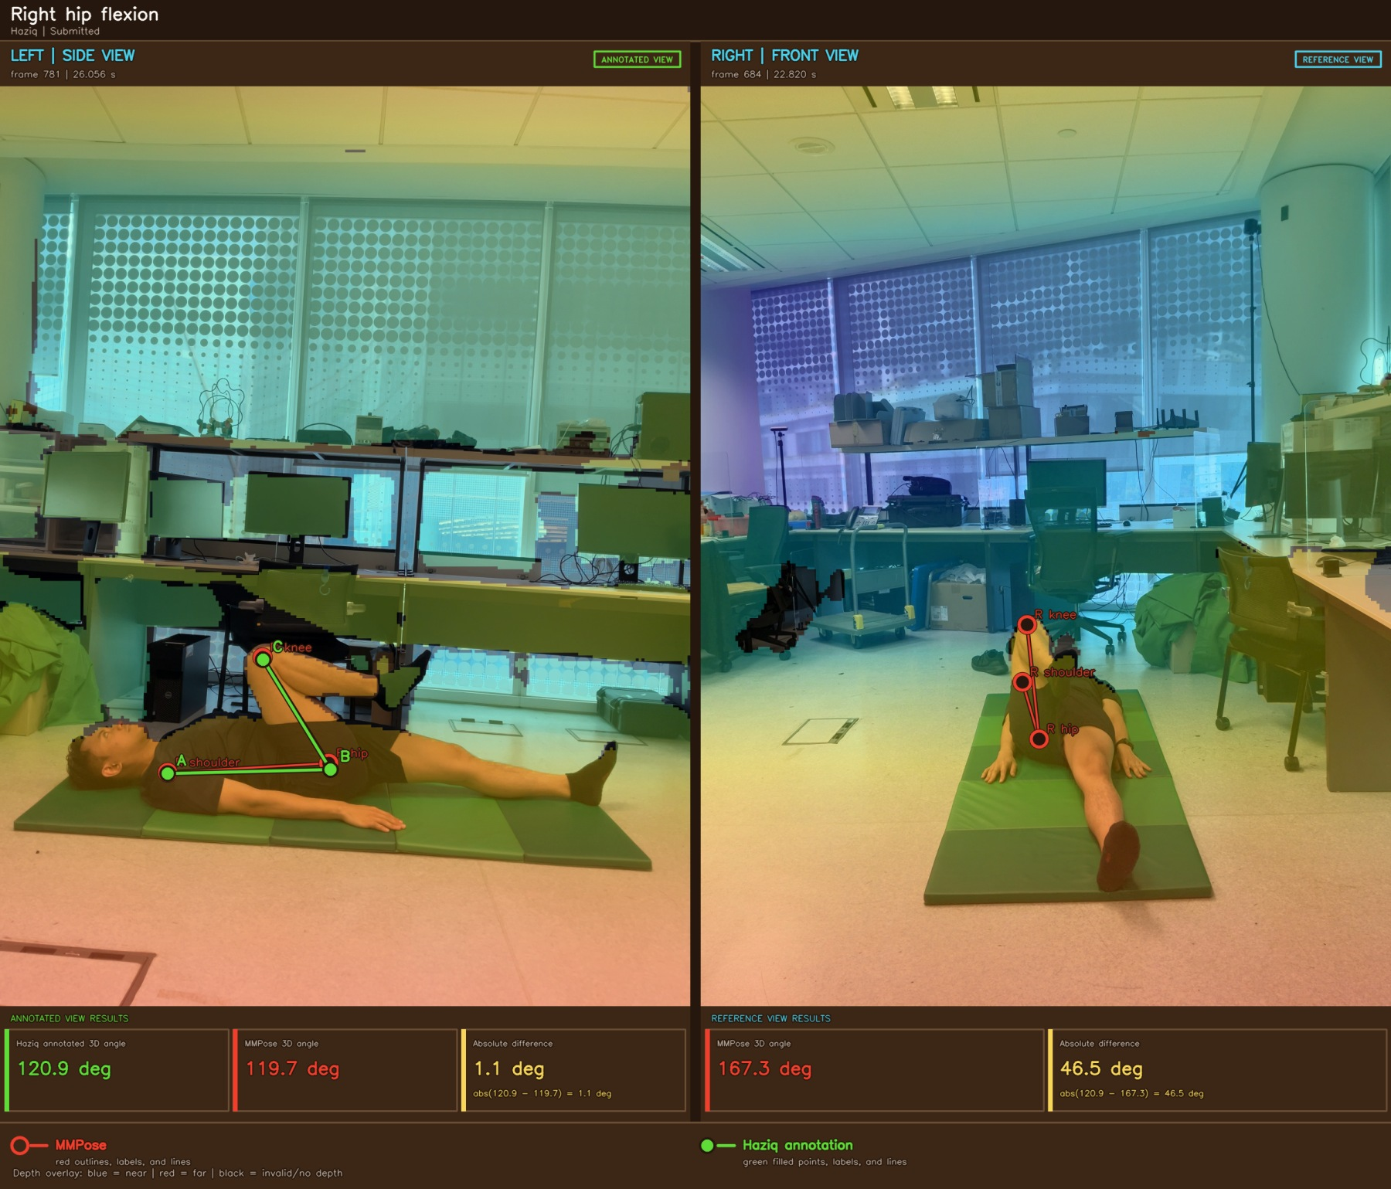
Figure A14 Right hip flexion example 2

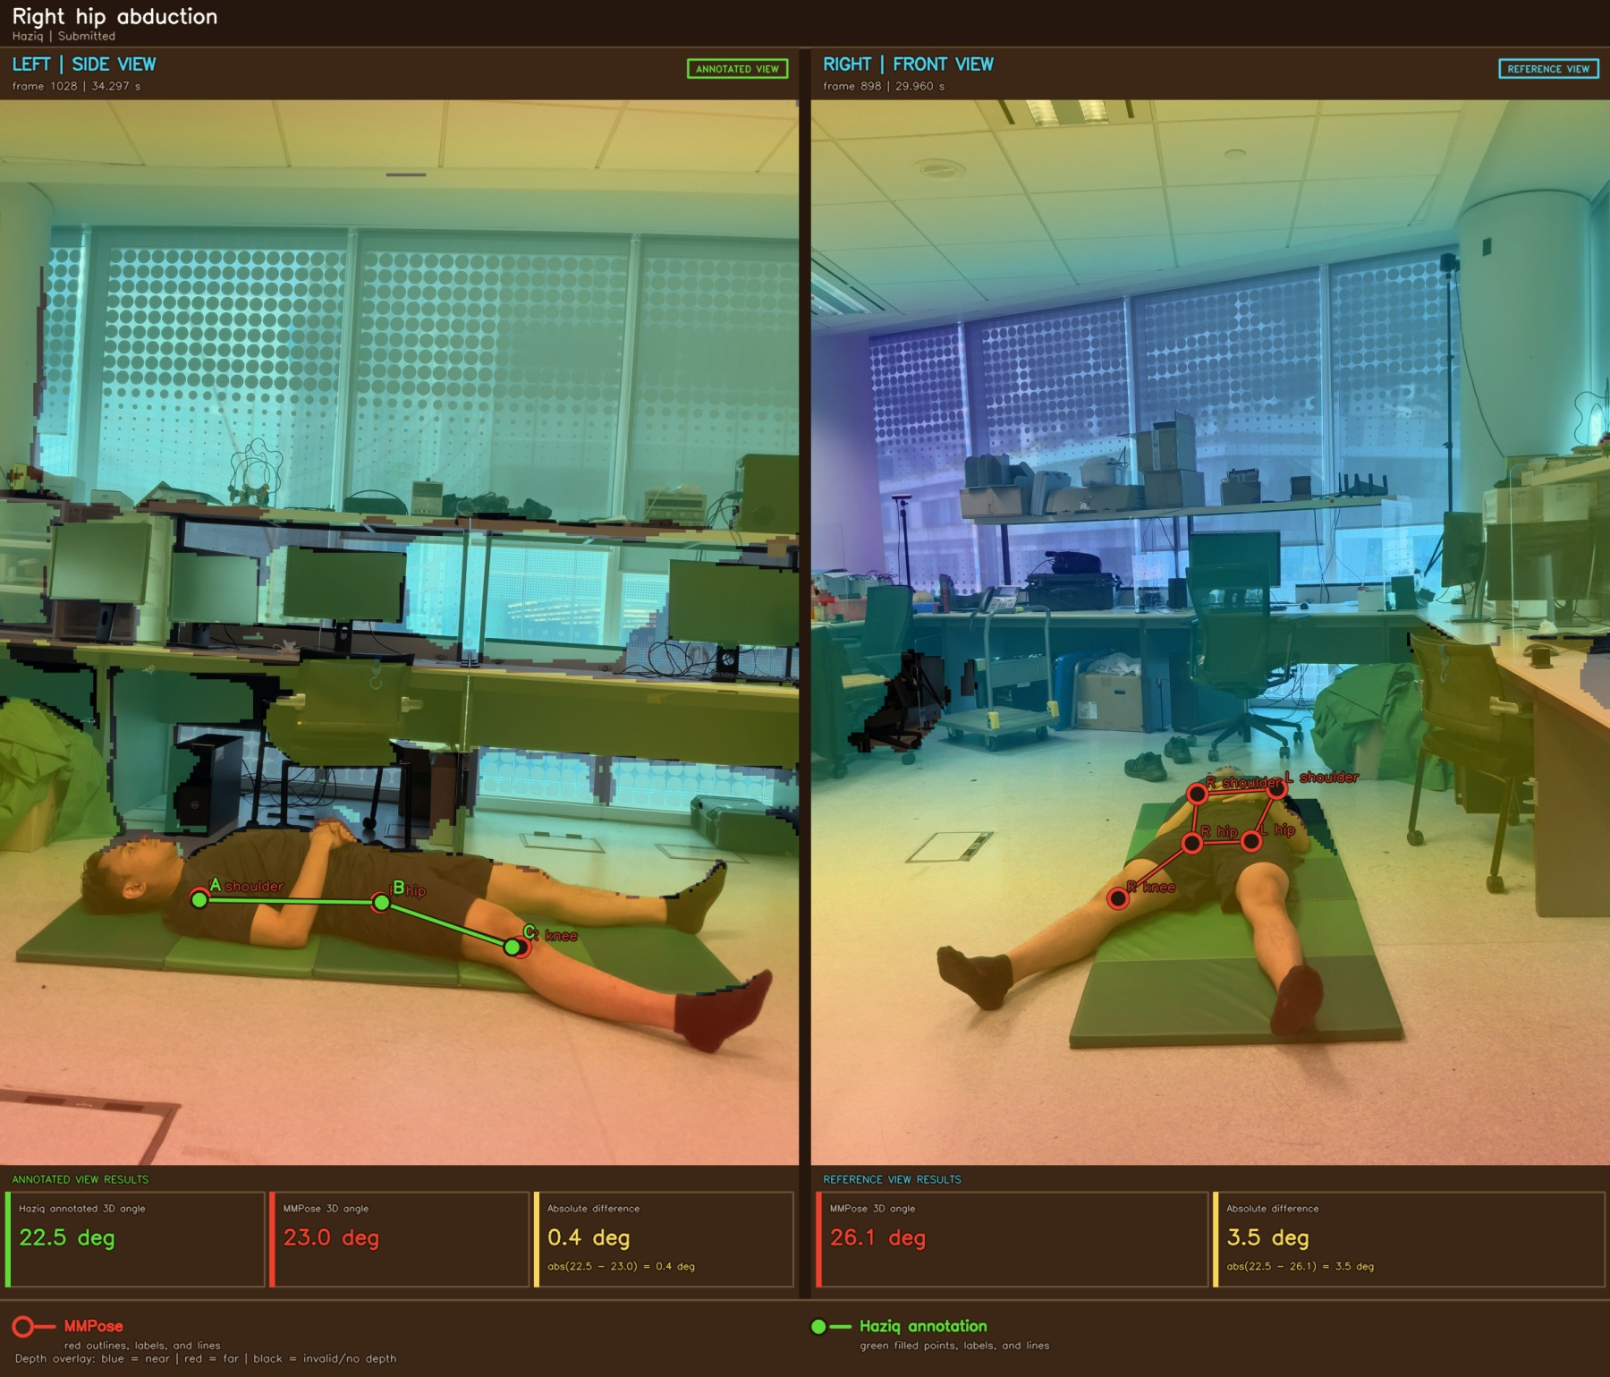
Figure A15 Right hip abduction example 1

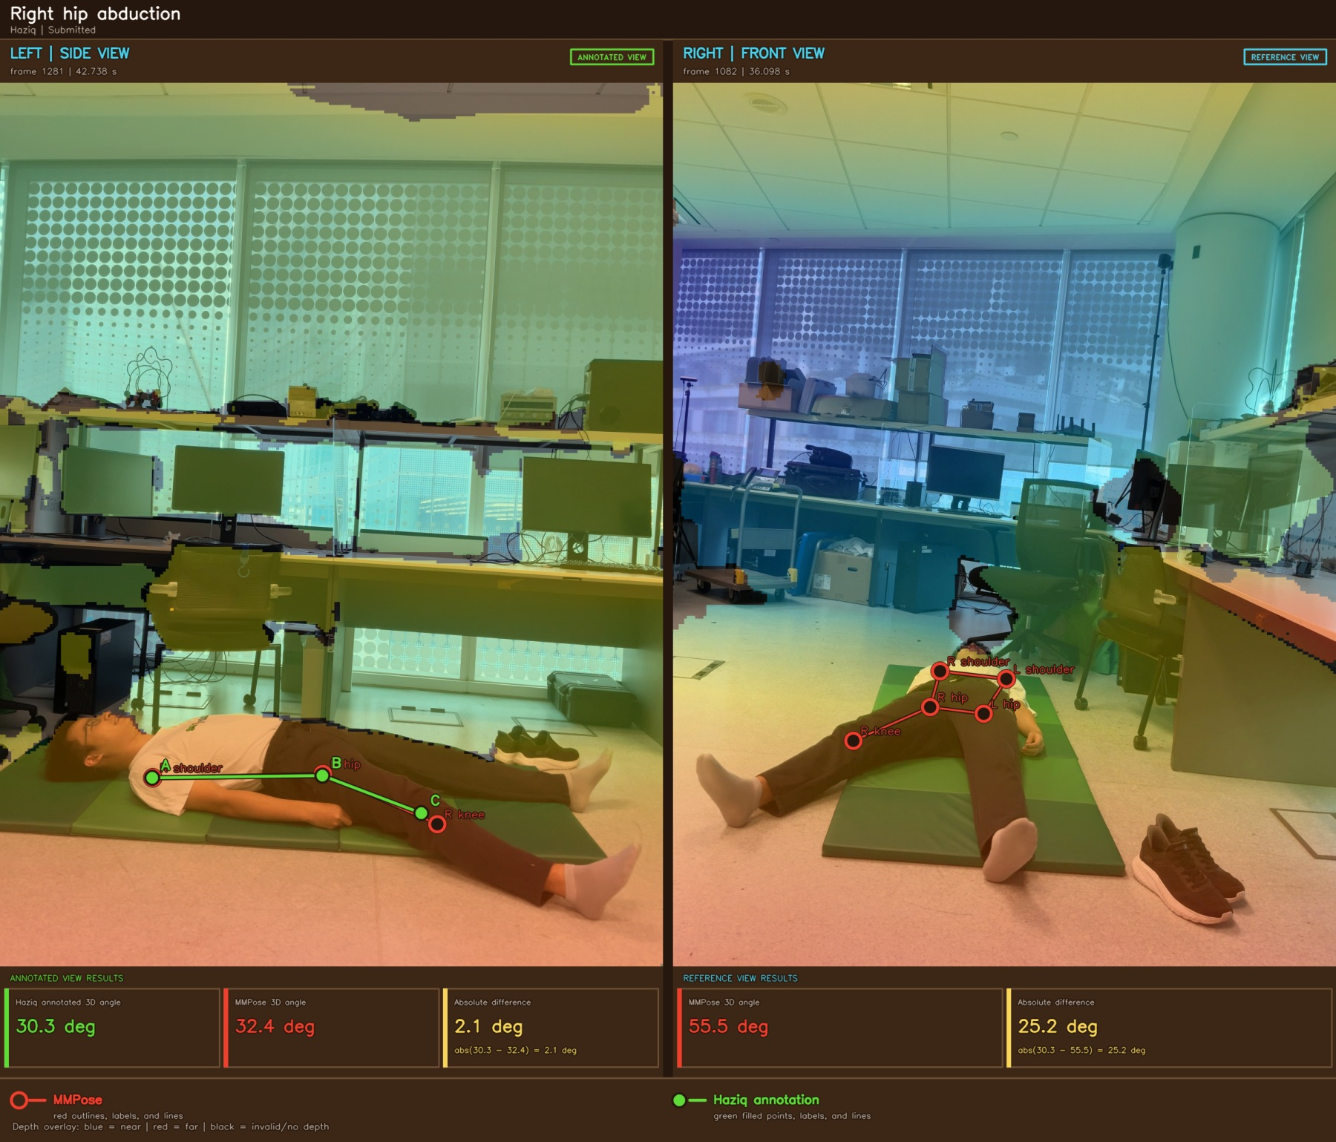
Figure A16 Right hip abduction example 2

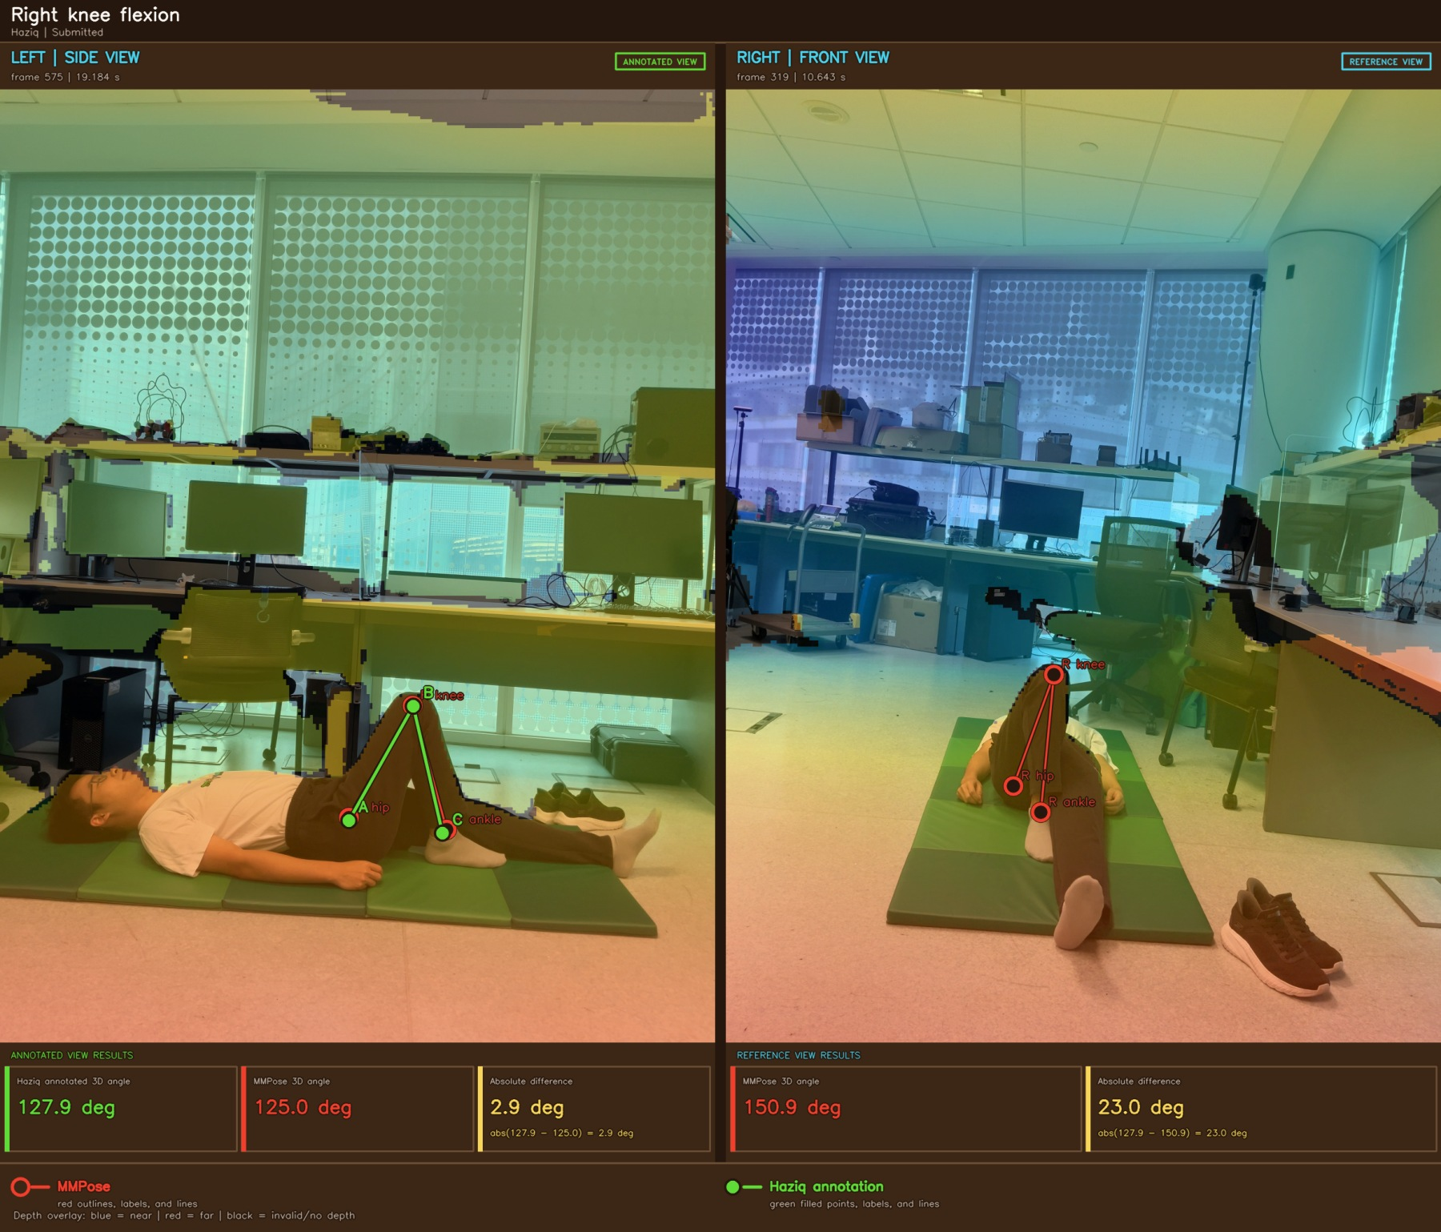
Figure A17 Right knee flexion example 1

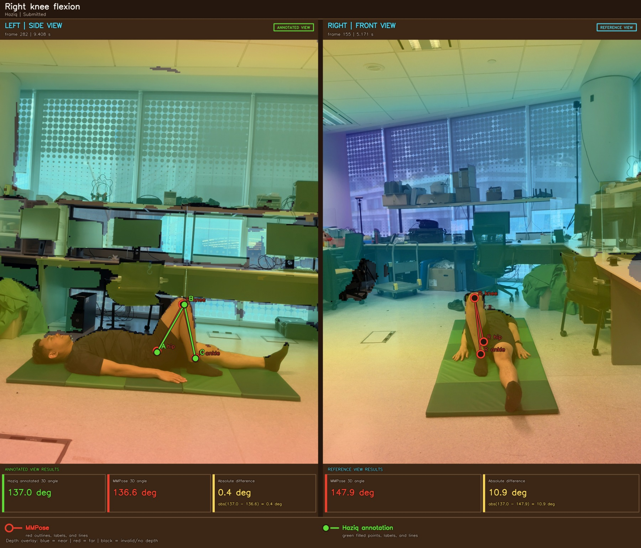
Figure A18 Right knee flexion example 2

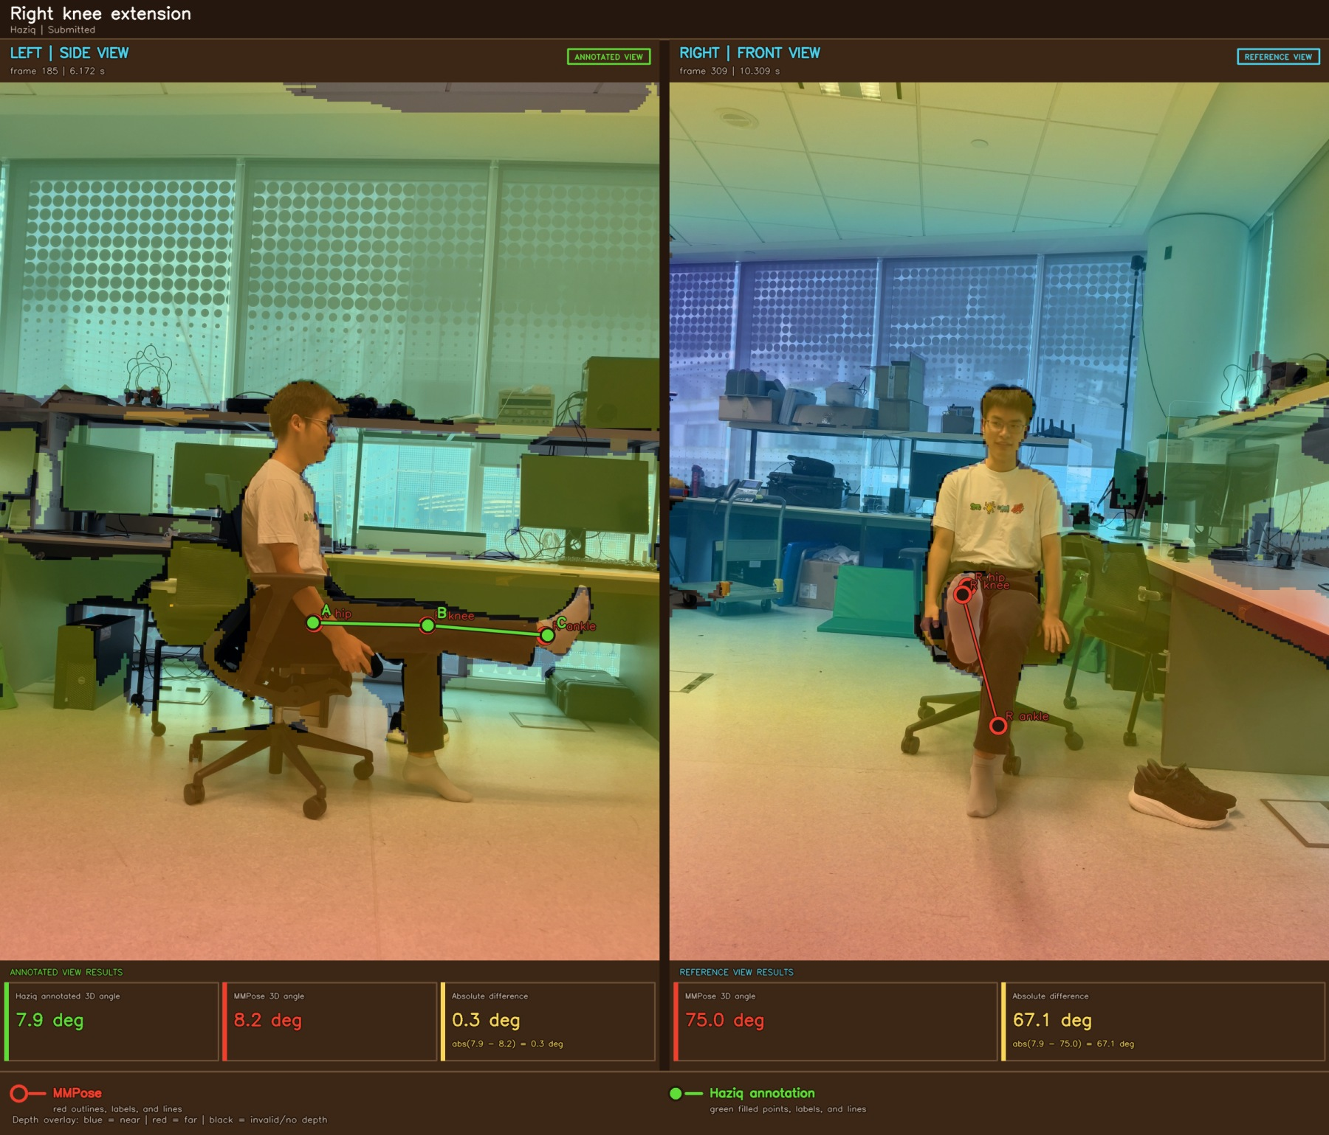
Figure A19 Right knee extension example 1

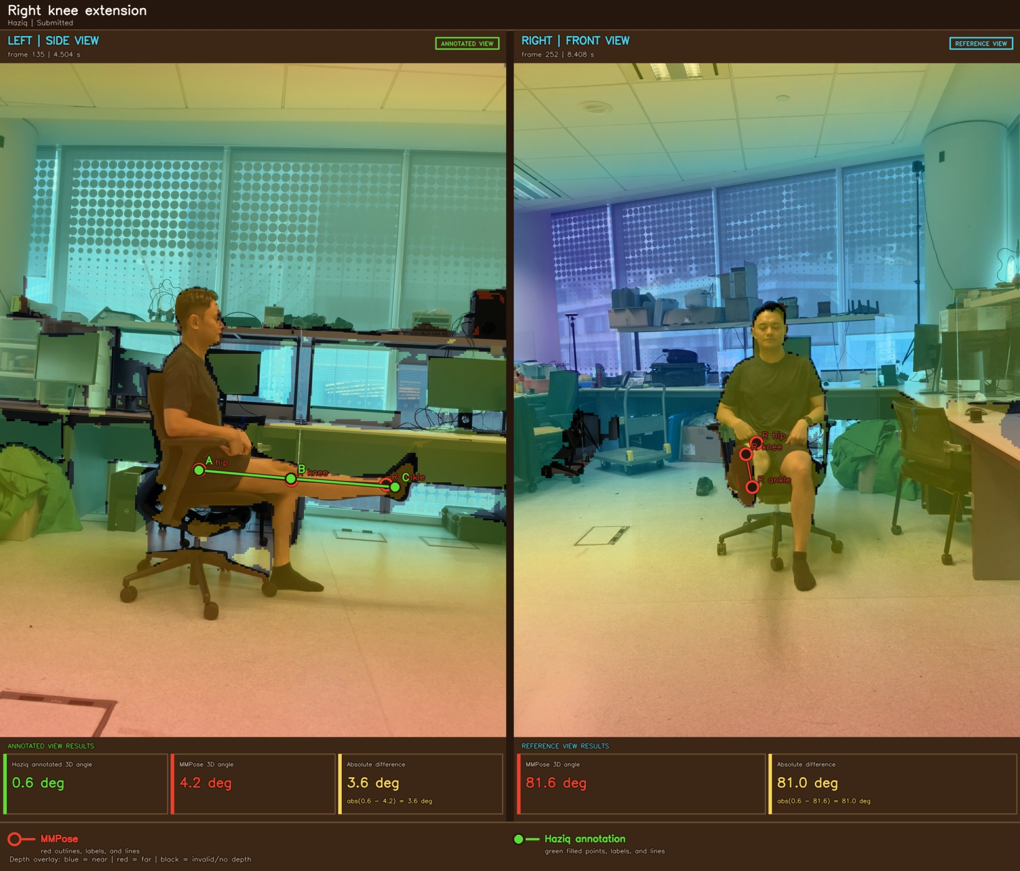
Figure A20 Right knee extension example 2

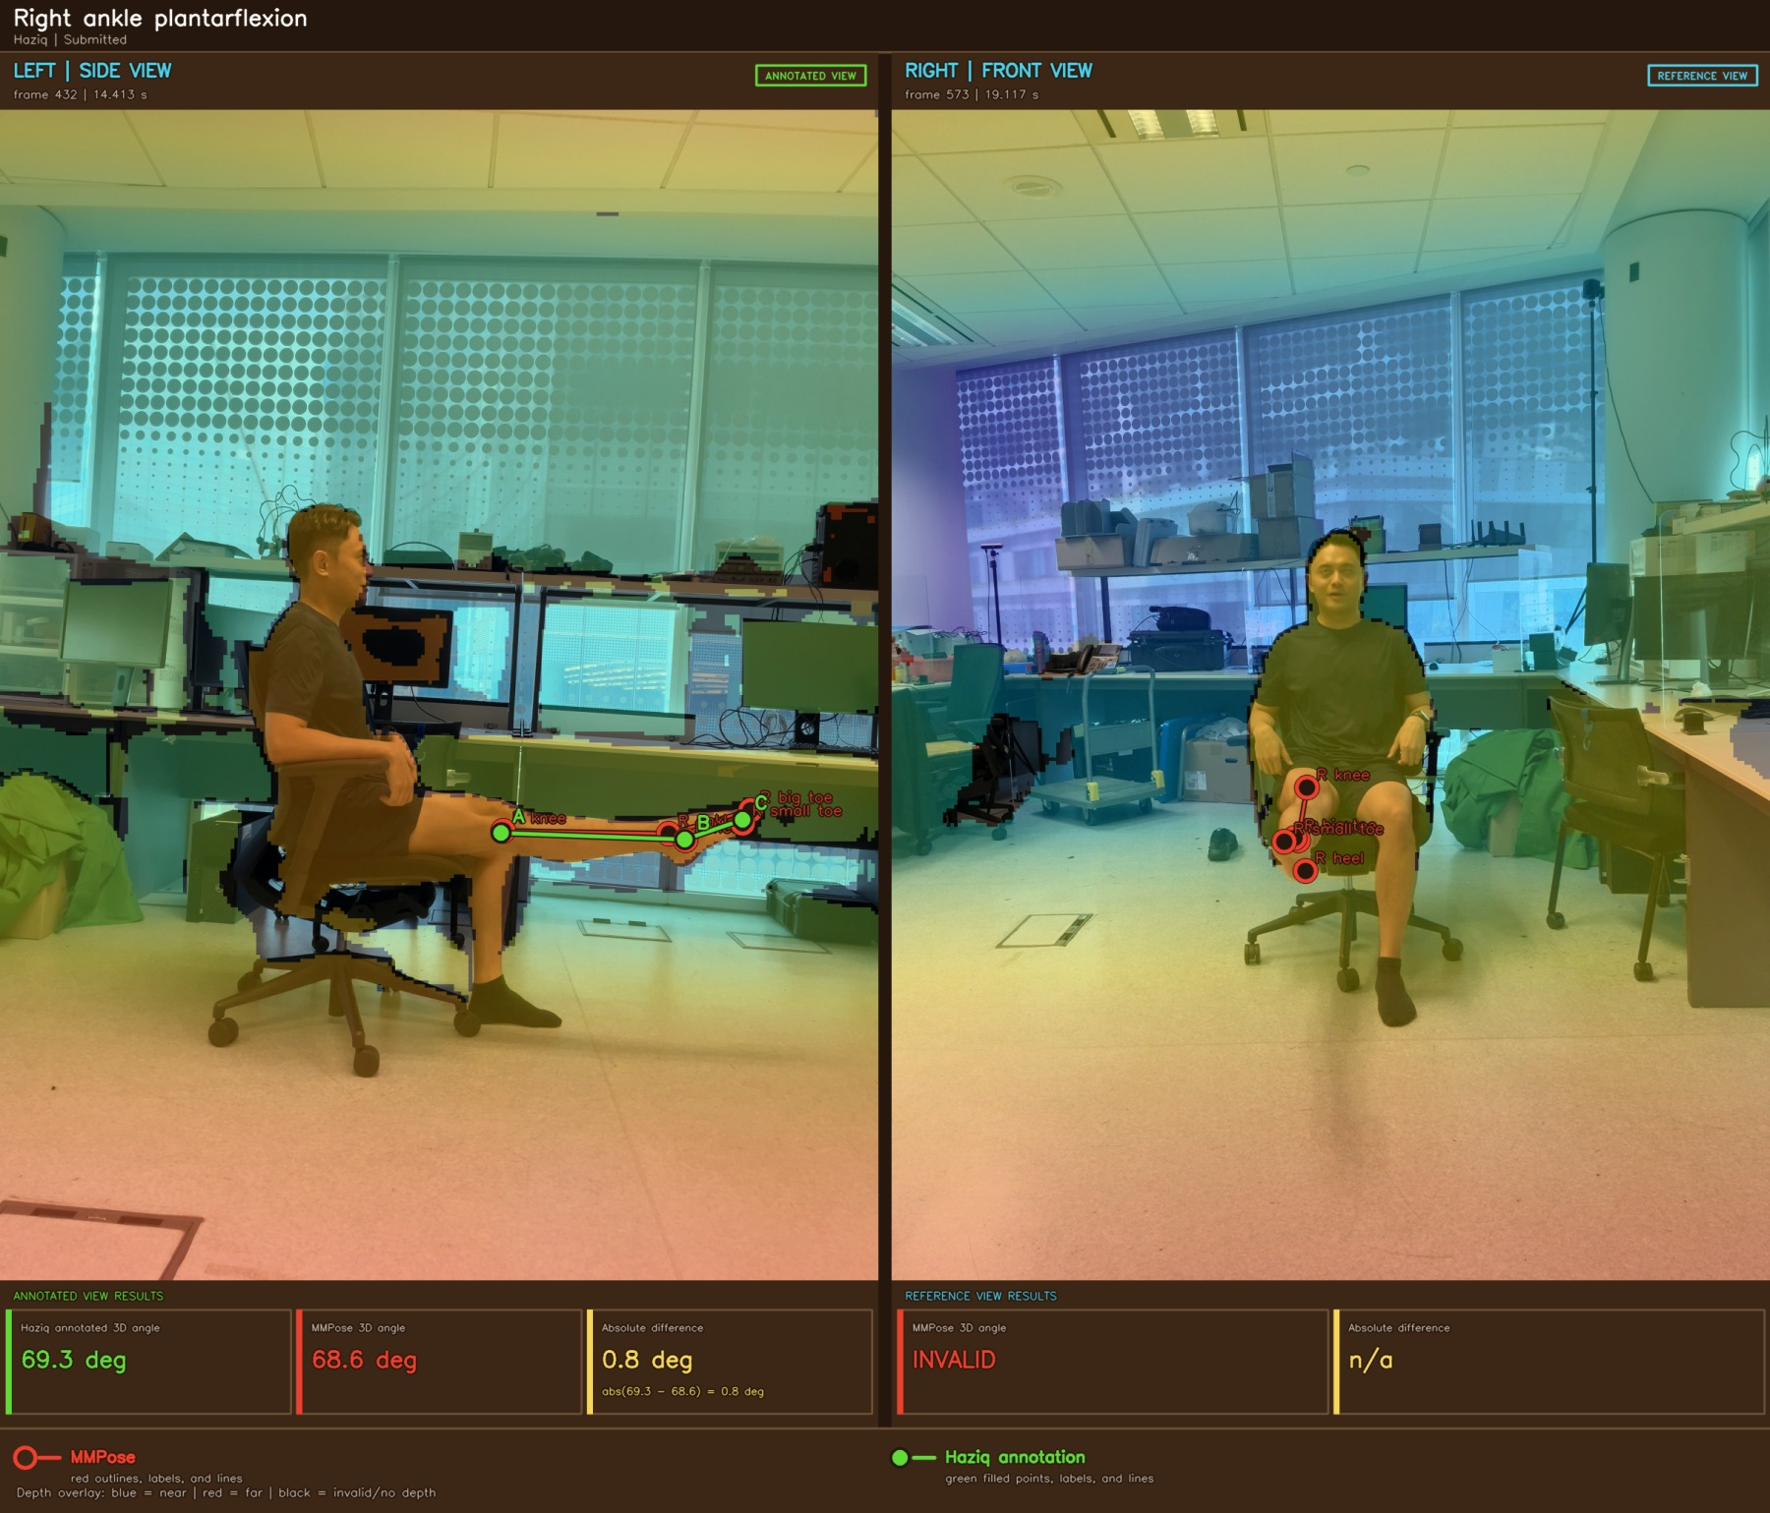
Figure A21 Right ankle plantarflexion example 1

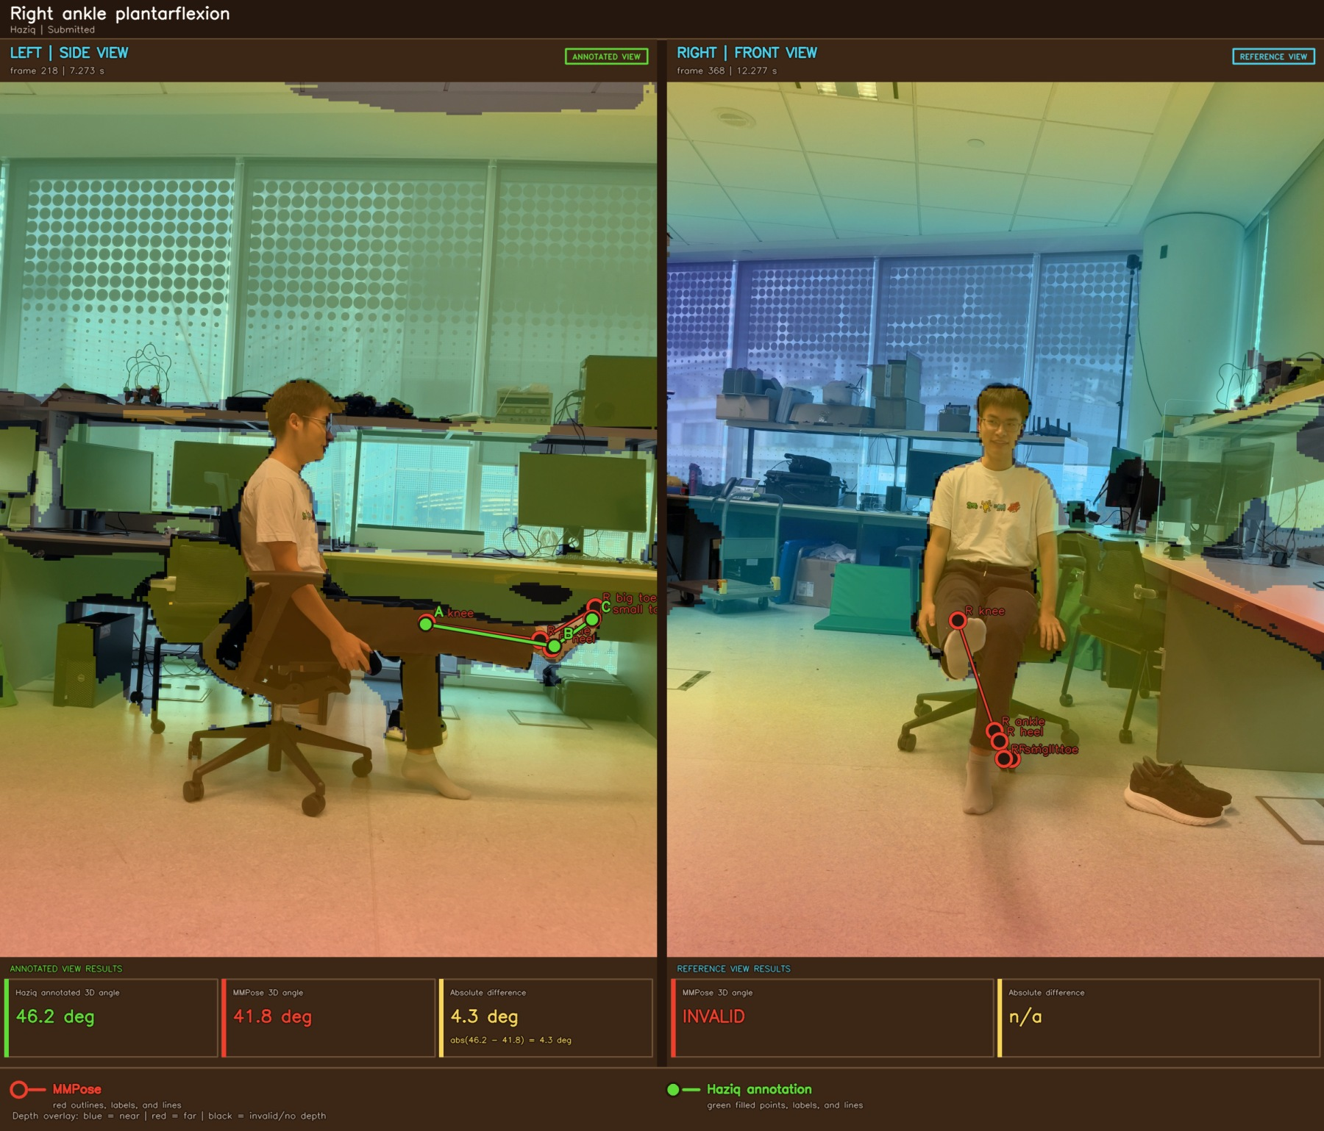
Figure A22 Right ankle plantarflexion example 2

Appendix B MHR Body Model Figures
These figures show ROM visualizations produced from the fitted MHR 3D body model. They are included as a model-based comparison to the RGB-D/MMPose results above.
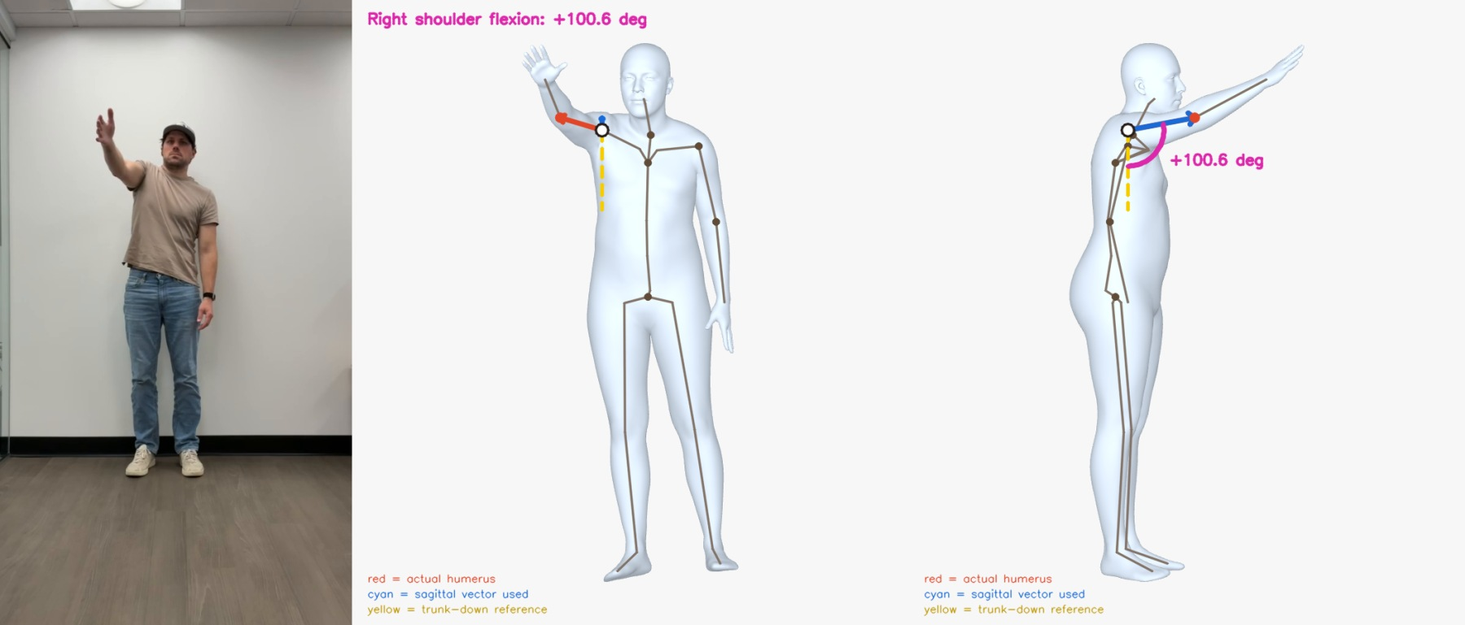
Figure B1 Shoulder Flexion at 10.076 s
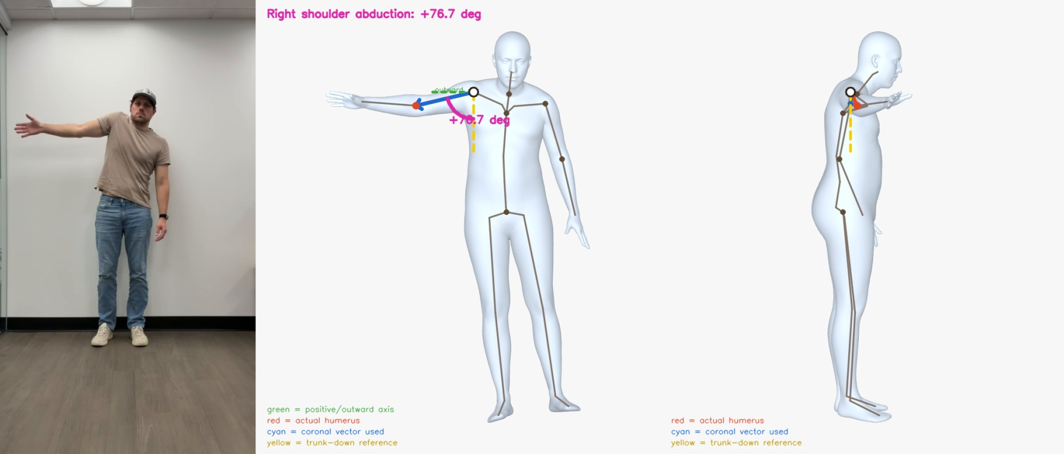
Figure B2 Shoulder Abduction at 14.180 s

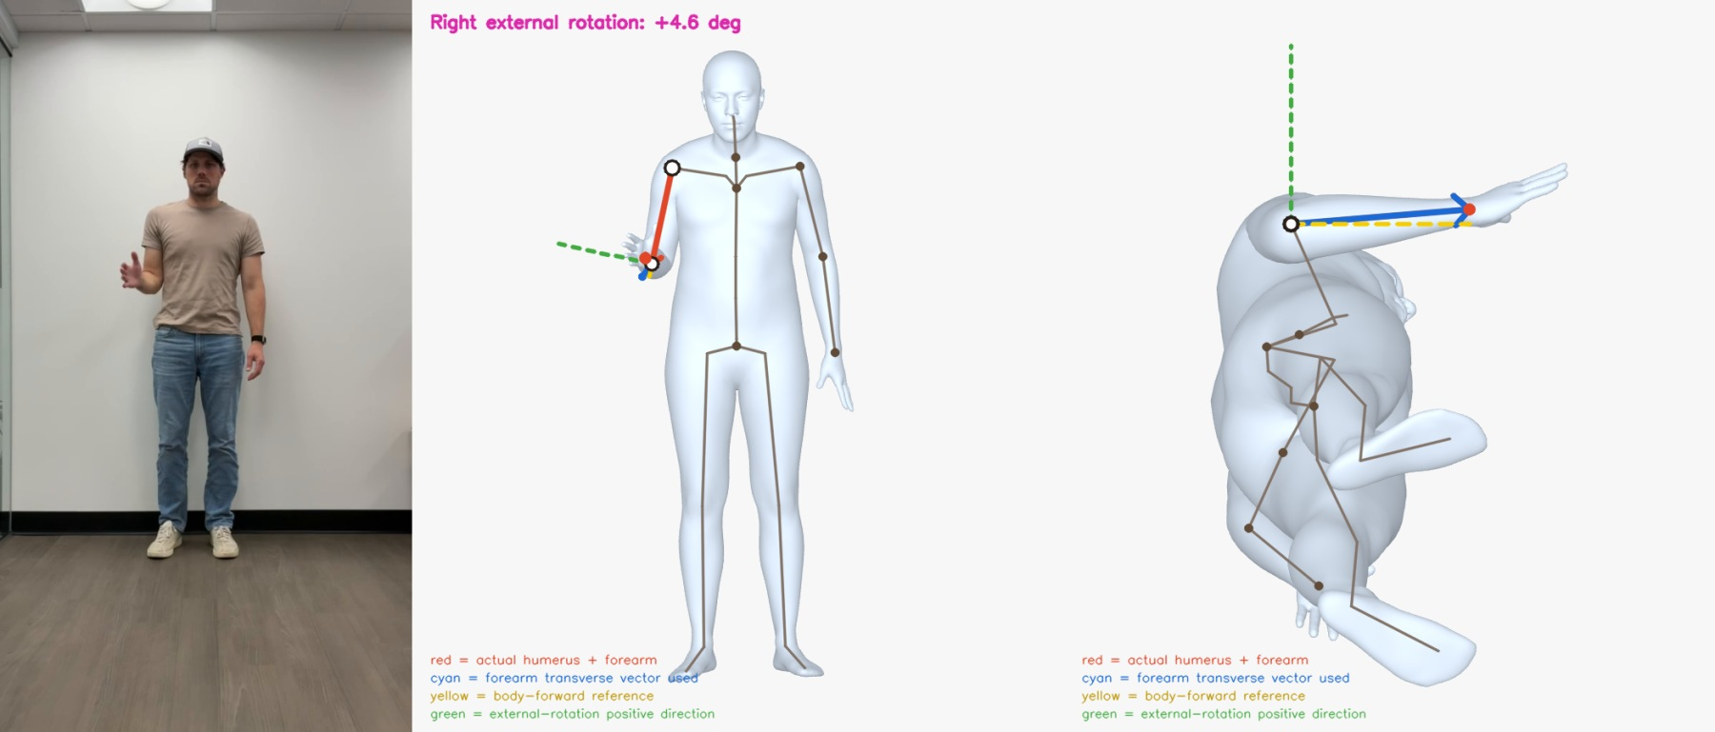
Figure B3 Shoulder External Rotation at 18.918 s
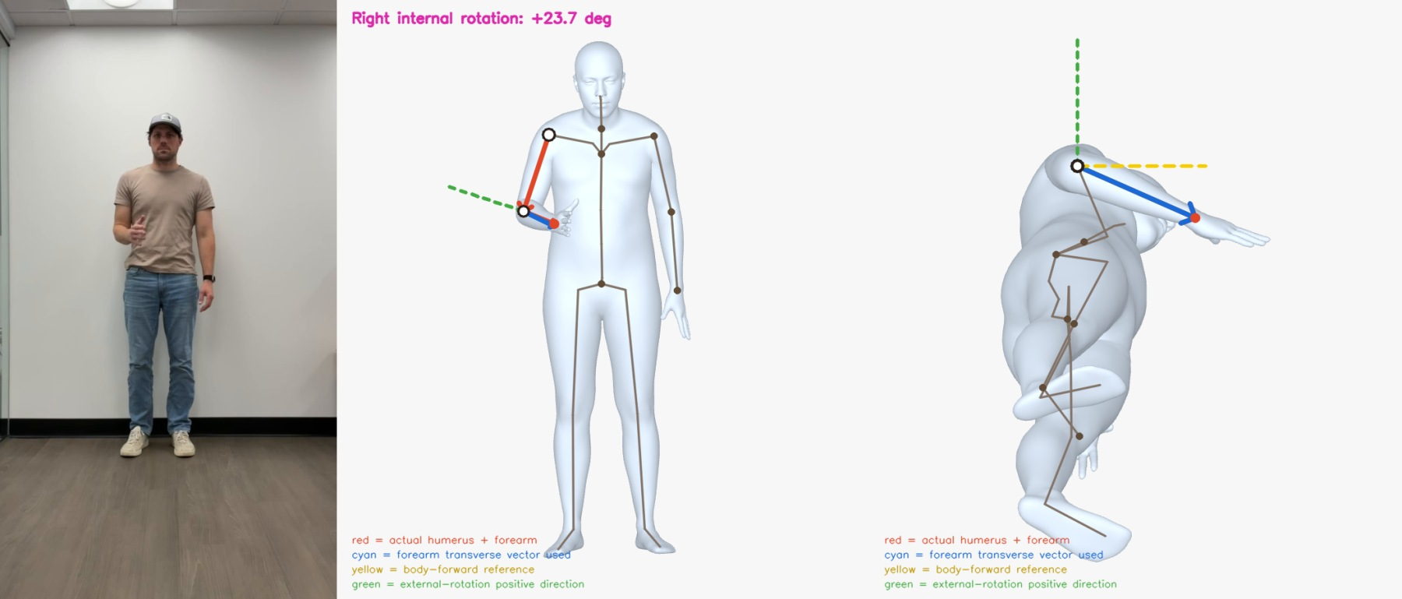
Figure B4 Shoulder Internal Rotation at 20.085 s

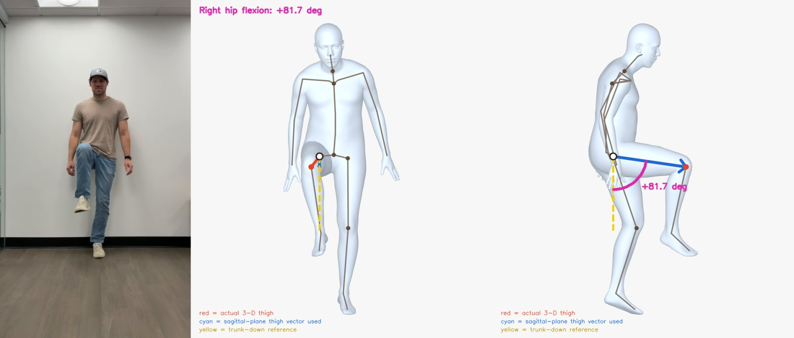
Figure B5 Hip Flexion at 9.175 s
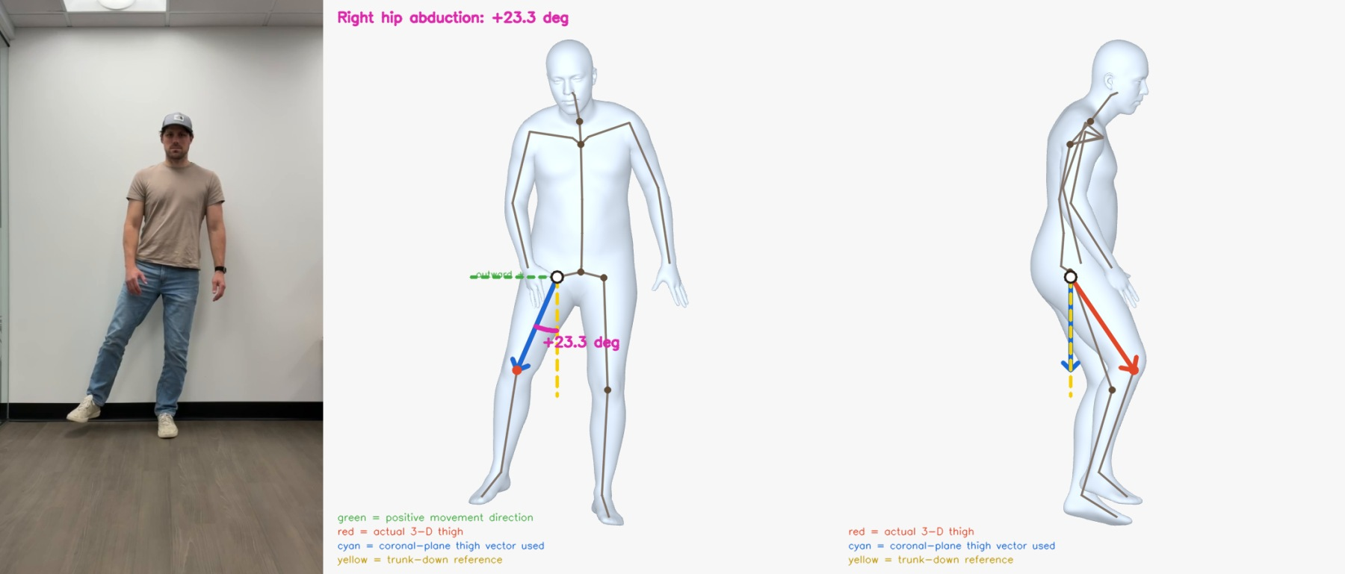
Figure B6 Hip Abduction at 22.720 s

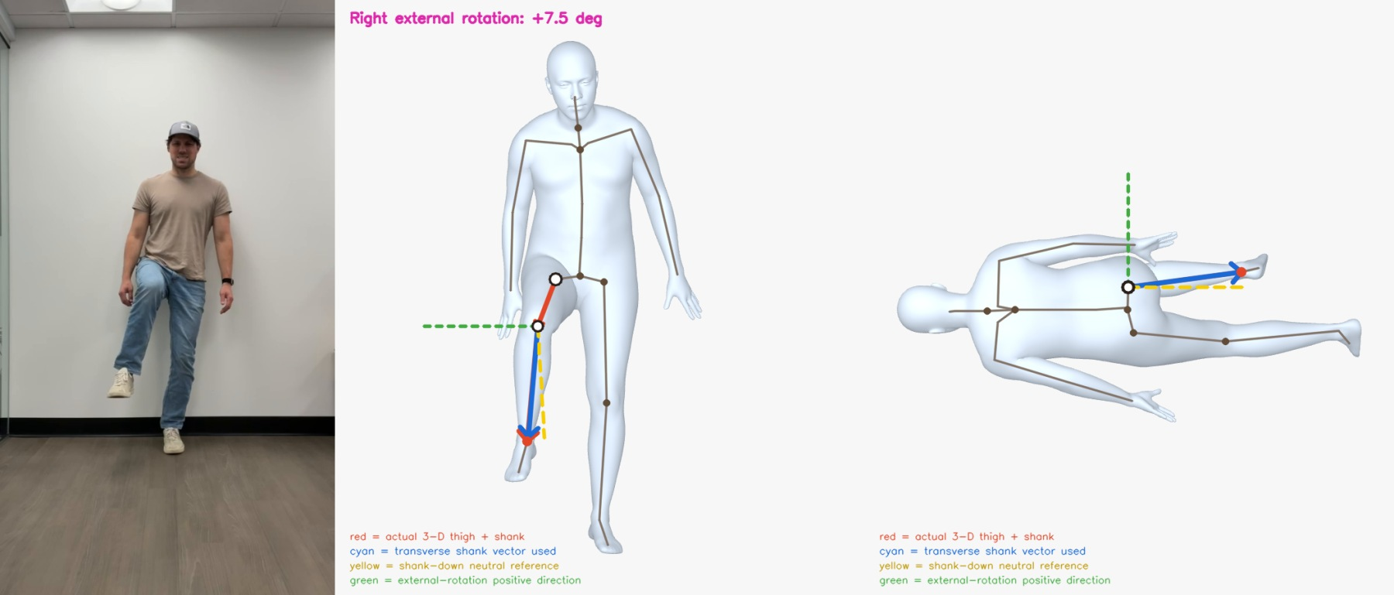
Figure B7 Hip External Rotation at 18.283 s
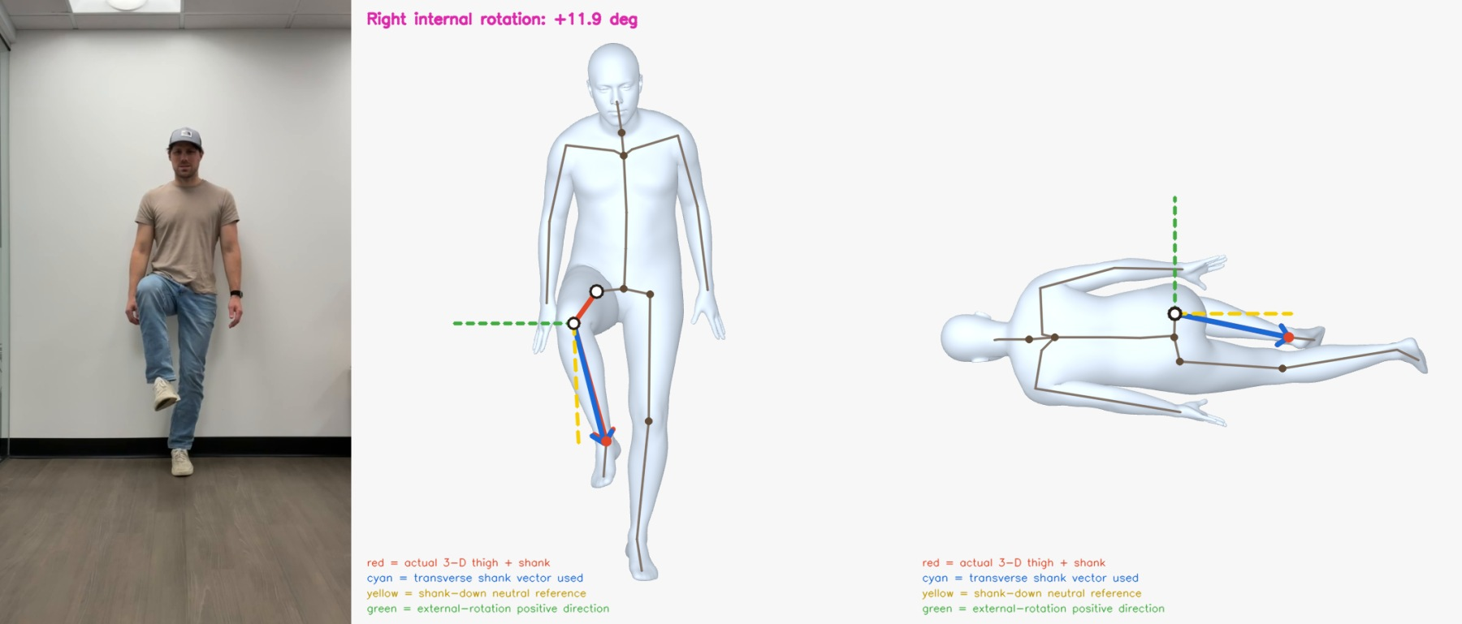
Figure B8 Hip Internal Rotation at 14.446 s

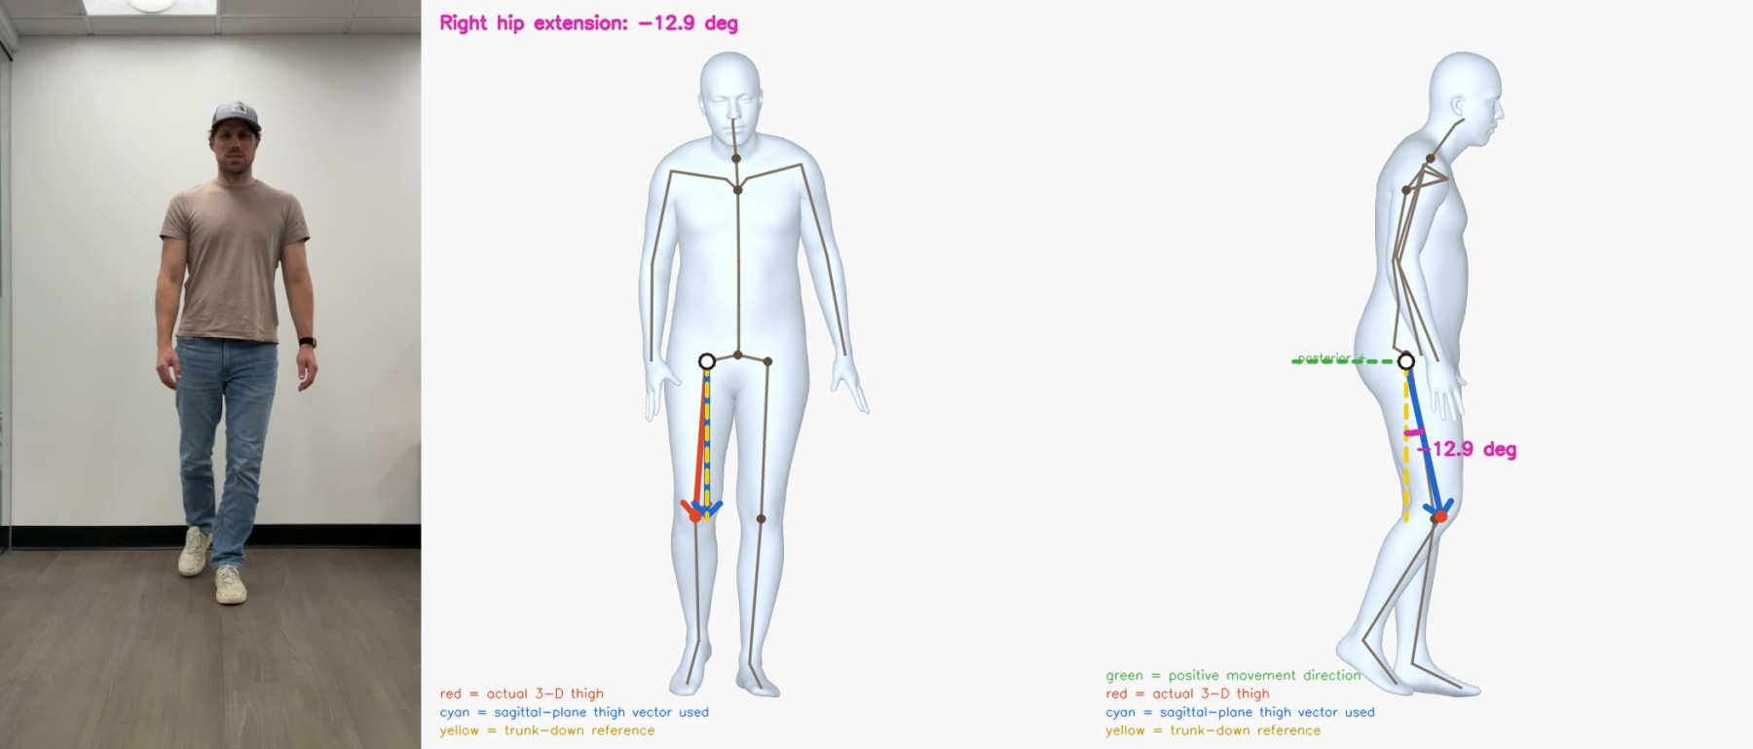
Figure B9 Hip Extension at 27.291 s

